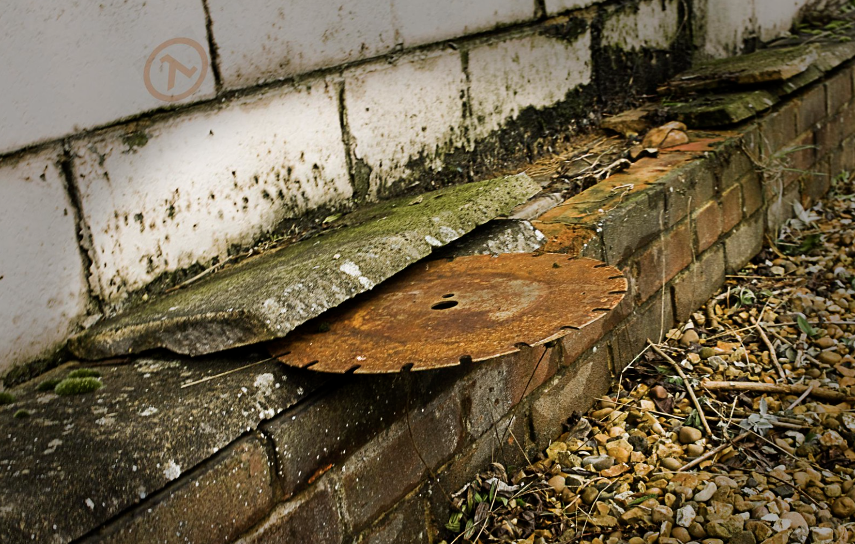
[Cover Image]

Half-Life 2: The Sawblade Factory
  - Version 1.0
Designer: | Wilbur Wang
Document Date: | 10/30/2023
Intended Level Delivery Date: | 11/6/2023

Document Revisions Table
Version | Description | Requestor | Date
1.0 | Initial Document | Professor Ouellette | 10/30/2023

Table of Contents
Table of Contents 2
Table of Figures 4
Level Summary 5
Quick Summary 5
Level Feature Overview 5
Development Schedule 6
Level Overview 7
Map Scale 7
Overview Map 8
Level Details 11
Detail Maps 11
Section 1: Entrance Elevator & Starting Room 11
Section 2: Raw Material Processing Room 13
Section 3: Heating Room 15
Section 4: Waterwheel Engine Room & Cooling Room 17
Section 5: Pier & Water Wheel 19
Section 6: Power Supply Room & 2nd Floor of Cooling Room 21
Section 7: Cutting Room 23
Section 8: Terrace & Exit Elevator 25
Skill Progression Chart 26
Aesthetic References 27
Visual Theme 1: Interior Theme 28
Visual Theme 2: Exterior Theme 29
References 30
Appendices 31
Appendix A: New Skills / Gameplay Mechanics 31
Use the Sawblade as a Platform 31
Use the Sawblade as a Conductor 31
Use the Sawblade as a Blocker 31
Appendix B: Context Detail 32
General Context 32
Backstory 32
Aftermath 32
Appendix C: Character Descriptions (N/A) 33
NPC 1: N/A 33
NPC 2: N/A 33
Appendix D: Dialog Flow (N/A) 34
NPC 1: N/A 34
Appendix E: Development Risks 35
Appendix F: Key Asset Needs 36

Table of Figures

Figure 1: Map Scale [1] 7
Figure 2: Overview Map [1] 8
Figure 3: Overview Walkthrough [1] 9
Figure 4: Section 1 Overview Map [1] 11
Figure 5: Section 2 Overview Map [1] 13
Figure 6: Section 3 Overview Map [1] 15
Figure 7: Section 4 Overview Map [1] 17
Figure 8: Section 5 Overview Map [1] 20
Figure 9: Section 6 Overview Map [1] 21
Figure 10: Section 7 Overview Map [1] 23
Figure 11: Section 8 Overview Map [1] 25
Figure 12: Skill Progression Chart 26
Figure 13: Contact Sheet for Interior Theme [2, 3, 4, 5, 6, 7, 8] 28
Figure 14: Contact Sheet for Exterior Theme [2, 9, 10, 11, 12, 13, 14] 29

Level Summary

Quick Summary
"The Sawblade Factory" is a single player first-person shooting level in Half-Life 2, which contains many puzzles with the theme of Sawblades.
This level's story is an independent "what If" chapter separated from the main game's narrative, where it follows Freeman as he drives on Highway 17 and encounters a collapsed section ahead. To get through, Freeman must use an elevator in a factory located beneath the highway near the coastline. This is a Sawblade factory occupied by the Combine forces, where Freeman has to fight a fierce battle with them using Sawblades.
This level is designed to explore the expandability of the Sawblade as a puzzle-solving element.

Level Feature Overview
Category | Sub-Category | Feature List
Player | Player Weapons | - Gravity Gun  - Shotgun
 | Player Skills/Abilities | - Move  - Jump  - Squat  - Interact  - Use the Gravity Gun  - Stand on the Sawblade
AI | Enemies | - Combine Soldier  - Combine Elite  - Manhack
 | Friendlies | - N/A
Challenges | Gameplay Themes | - Using Sawblades to battle and solve puzzles
 | Obstacles/Hazards | - Broken wire
 | New/Unique Gameplay | - Using the Sawblade as a Platform  - Using the Sawblade as a Conductor  - Using the Sawblade as a Blocker
Context | Where Fits in Game | - A “what if” chapter separated from the main game's story, which tells the story happened on Highway 17.  - The properties of the Sawblade match the physics theme of the main game.
 | Challenge Fit | - The level takes place in the "Highway 17" chapter of the main game. Currently, the player has just mastered the skill of using a Sawblade as a weapon. This level can strengthen this skill and teach the player new skills about the Sawblade.
 | Additional Info | - N/A
Aesthetics | Major Visual Themes | - City 17  - Factory
 | Setting/Mood | - Gloomy  - Depressing

Development Schedule
Milestone | Date
LDD | 10/30/2023
Whitebox | 11/6/2023
Initial Gameplay | 11/13/2023
Gameplay Complete | 11/20/2023
Aesthetics | 11/27/2023
Launch | 12/4/2023

Level Overview

Map Scale
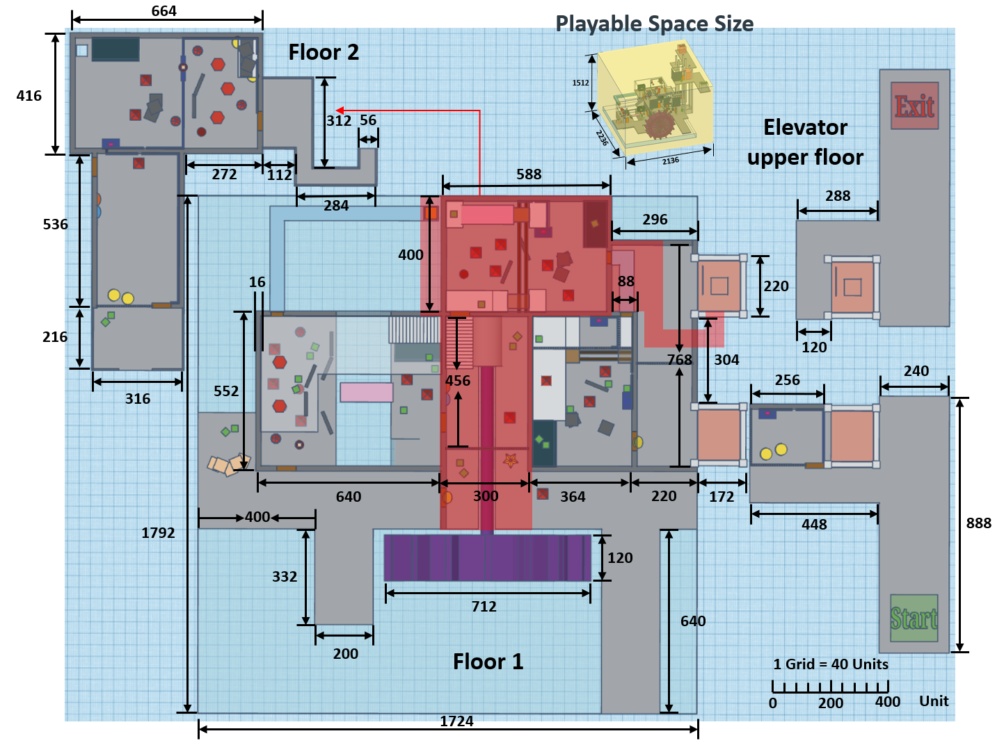
Figure 1: Map Scale [1]

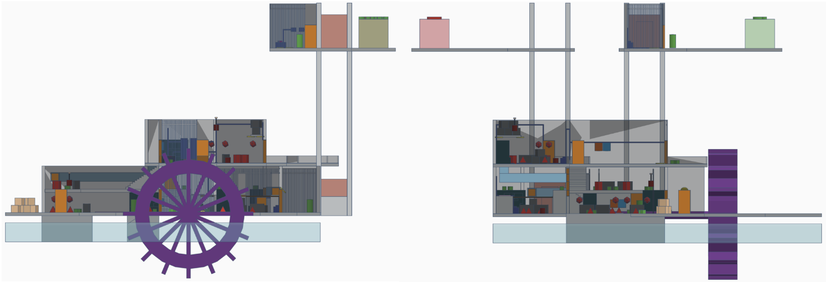
Overview Map
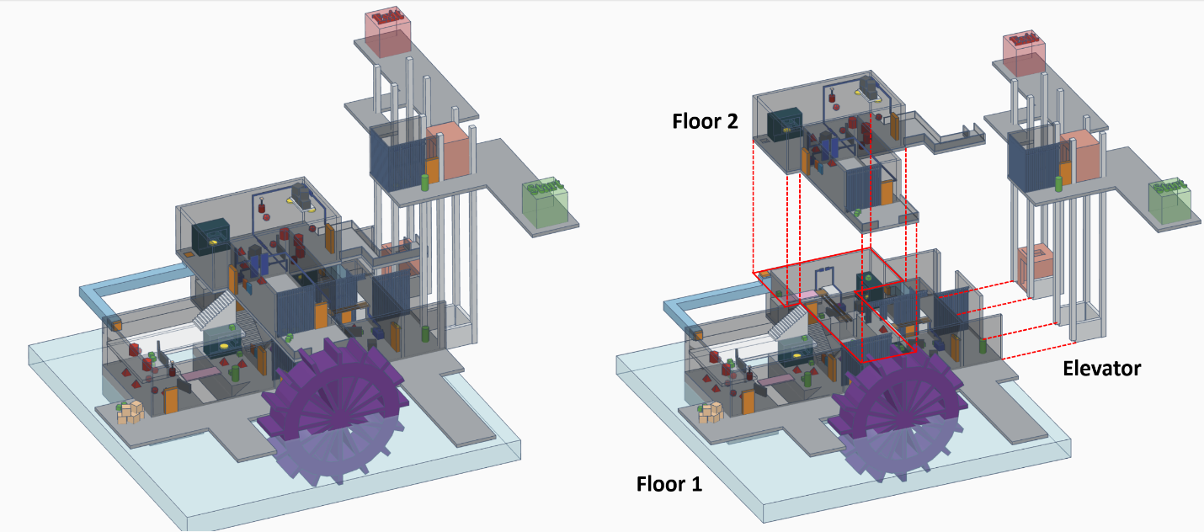
Figure 2: Overview Map [1]
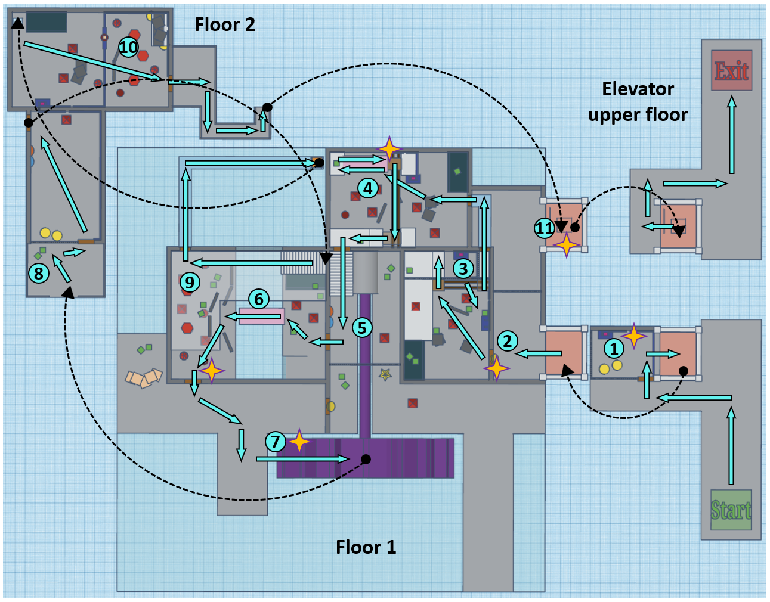
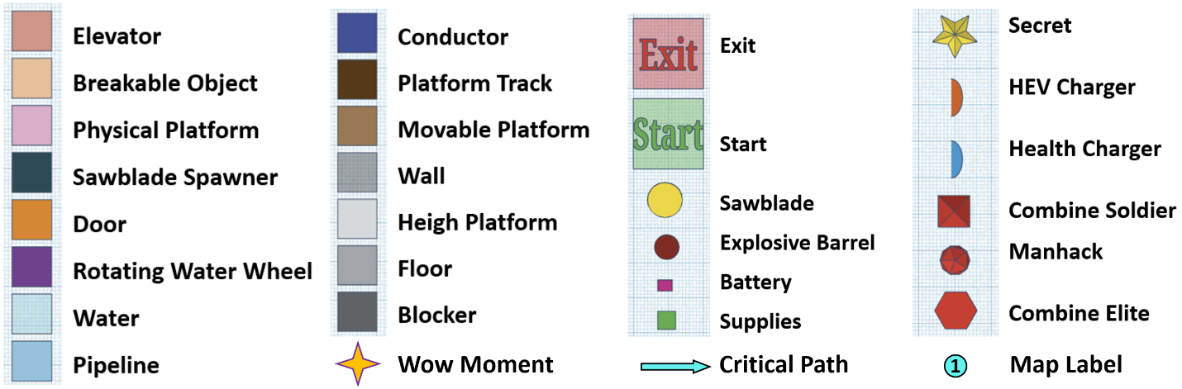
Figure 3: Overview Walkthrough [1]
Map Label | Gameplay Summary
1 | The Player started on Highway 17 with the Gravity Gun and Shotgun. They found that the road ahead collapsed and could not be passed. They could only use the elevator in the factory at the bottom left of the road to reach the other side. The player uses the Sawblade as a Conductor to solve the puzzle, then enter the elevator and arrive at the factory.
2 | The player uses the Gravity Gun to grab the Sawblade blocking the door and enter the room.
3 | Players enter the Raw Material Processing room, kill enemies, and use Sawblades to solve a series of puzzles. In this room, players need to use the properties of the Sawblade as a Conductor, as a Blocker, and as a Platform to complete the decryption.
4 | Players enter the Heating Room through pipes, kill enemies, and use Sawblades to restore power to Movable Platforms to help them reach the exit. This room will enhance the player's ability to use the Sawblade as a Conductor.
5 | Players enter the Waterwheel Engine Room, kill enemies, and pick up supplies. This room gives players enough supplies to face the next fierce battle.
6 | Players enter the Cooling Room and engage in fierce battles with a large number of enemies. Players need to use Sawblades as obstacles to support the Physical Platform to reach the other side. This room focuses on combat and enhances the player's ability to use the Sawblade as a Blocker.
7 | Players walk to the outdoor pier, shoot the Sawblade onto the water wheel, and use the water wheel to transport themselves to the second floor. This room will enhance the player's ability to use the Sawblade as a Platform.
8 | Players reach the balcony on the second floor and use the Gravity Gun to shoot the Sawblade to the broken wire and kill the enemy at the same time. Use charger to restore power and health. This room will enhance the player's ability to use the Sawblade as a Conductor, and make player intuitively realize the diversity function of the Sawblade.
9 | Players enter the higher floor of the Cooling Room. Kill the two Combine Elite. Use the Sawblade as a Platform to reach the entrance of pipe. This room will test the player's ability to use the Sawblade as a Platform.
10 | Players enter the Cutting Room and kill Combine enemies. Players need to use Sawblades to connect three broken wires. One of them is blocked by an obstacle. Players need to use the Gravity Gun to grab the Sawblade supporting the obstacle. This room will test the player's ability to use the Sawblade as a Conductor and a Blocker.
11 | Players enter the balcony and jump into the elevator, then takes the elevator to the upper exit to complete the level.

Level Details

Detail Maps

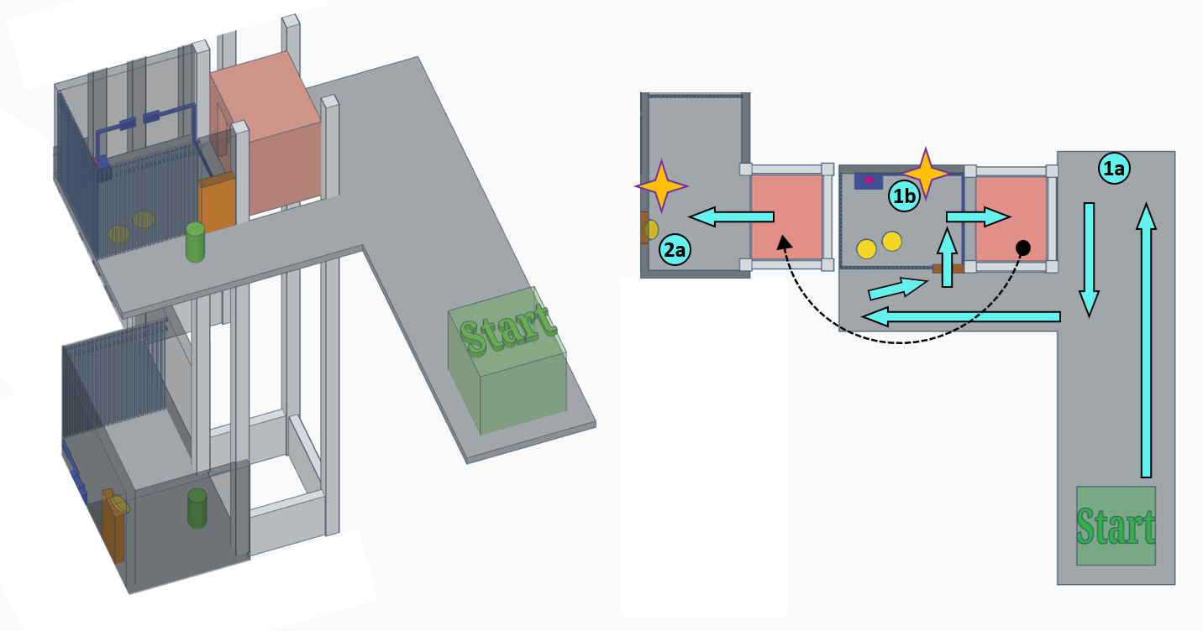
Section 1: Entrance Elevator & Starting Room
Figure 4: Section 1 Overview Map [1]
Map Label / Stage | Event Summary | Event Details | Wow?
1a | -Show Final Goal and the Whole Flow | Players start on Highway 17 with the Gravity Gun and Shotgun.  Players find that the road ahead collapsed and was unable to move forward normally, so they go to the left side of the road and look down and find that two elevators connected to the factory below. One elevator is on their side, and the other elevator is on the other side of the collapsed road, so players understand that they can go through the factory to reach the elevator on the other side, and then take the elevator to reach the other side of the collapsed road.
1b | -Puzzle  -Teaching New Mechanic: using Sawblade as a Conductor | The player walked to the room in front of the elevator and found that the door was locked. A broken wire connected the door and the power supply. The player found two Sawblades on the ground in the room. The material of Sawblades is metal, which can conduct electricity, so the player used the Gravity Gun to shoot the Sawblade to the place where the wire broke. Then the door restored power and opened automatically. The player entered the room and took the elevator to the factory. | Yes
2a | -Puzzle  -Teaching New Mechanic: using Sawblade as a Blocker | After entering the factory, the player found a door ahead but cannot open it. After careful inspection, the player found that the door was stuck by a Sawblade embedded in the wall, so the player used the Gravity Gun to grab the Sawblade. Then the door can be opened, and the player entered the next room. | Yes

Section 2: Raw Material Processing Room
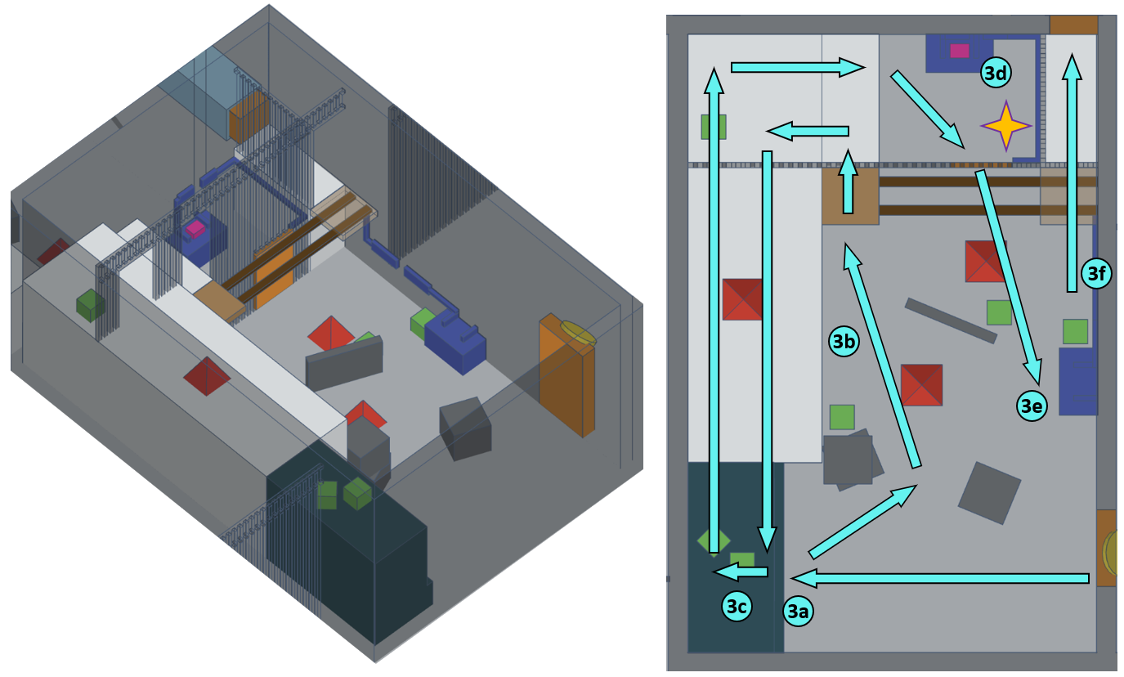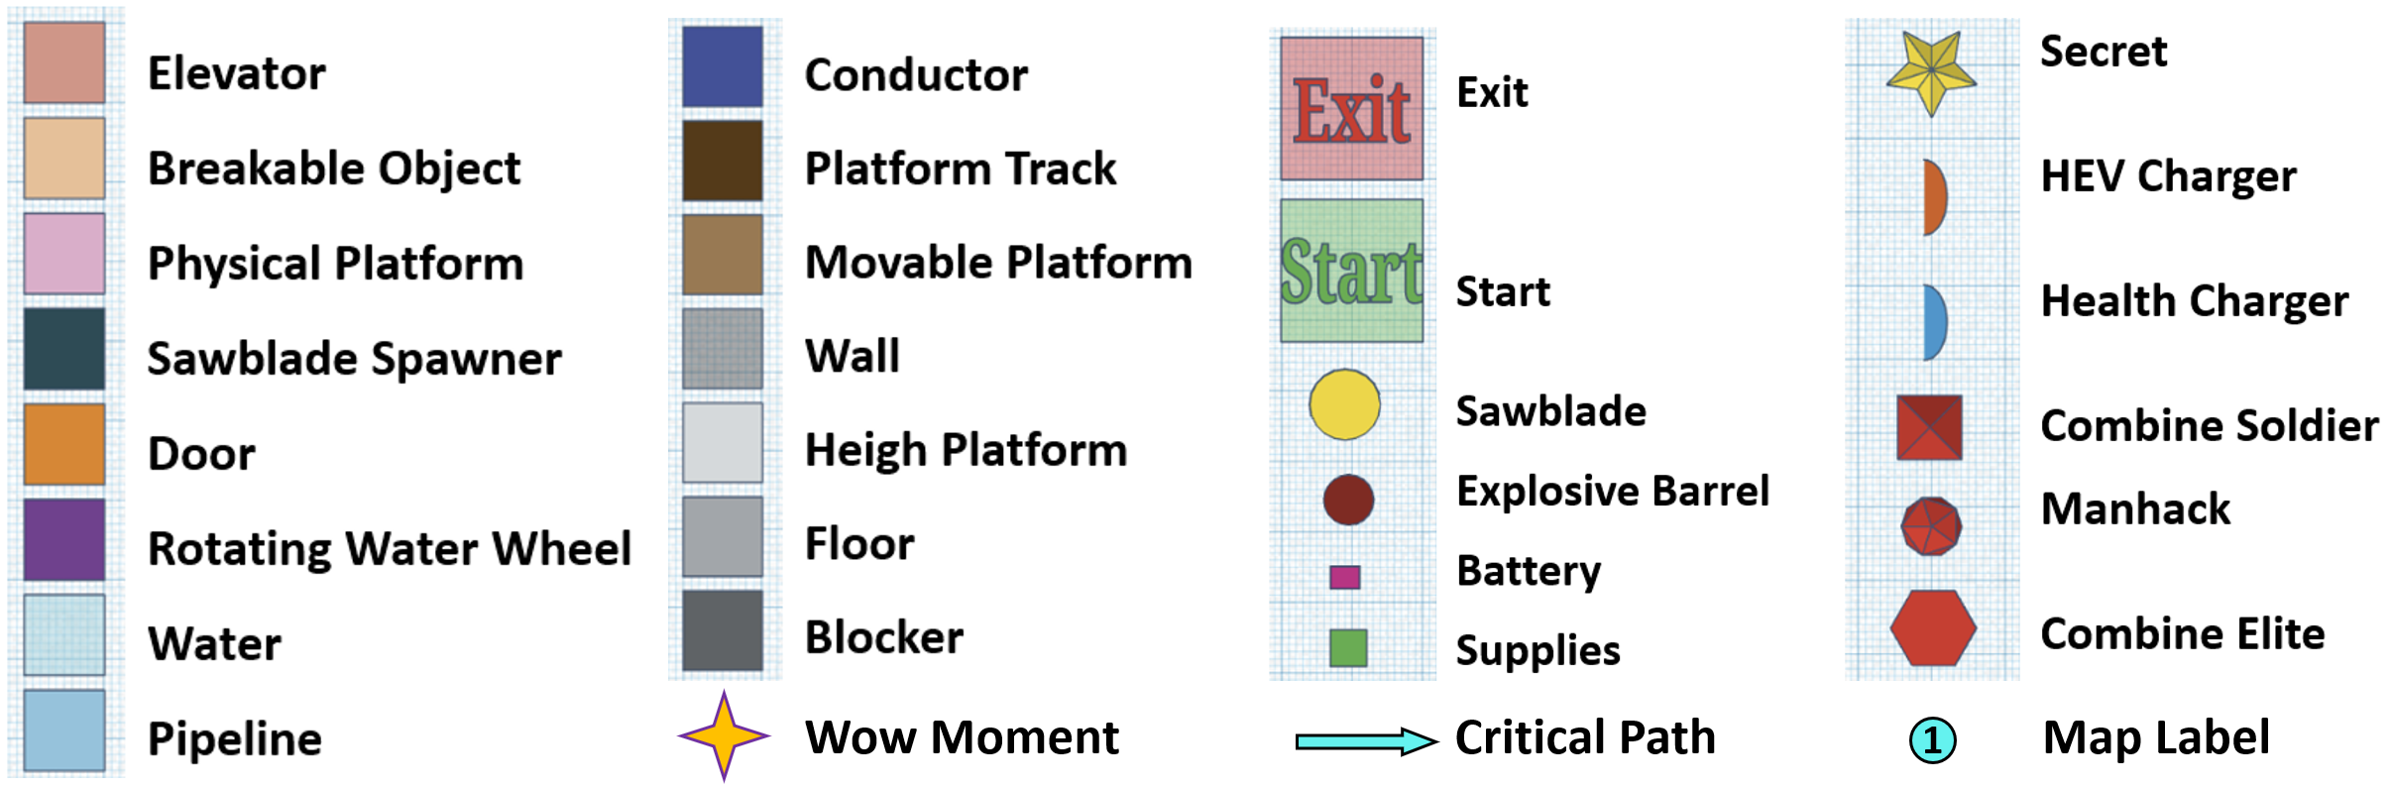
Figure 5: Section 2 Overview Map [1]
Map Label / Stage | Event Summary | Event Details | Wow?
3a | -Encounter | After the player enters the room, 3 Combine Soldiers will be spawned, 2 on the ground and 1 on the high platform. Players can kill them with a Shotgun, or they can use the Gravity Gun to grab the Sawblade from the Sawblade Spawner to kill them.
3b | -Skill Challenge  -Teaching New Mechanic: using Sawblade as a Platform | The player discovered that they need to power the Movable Platform to reach the exit, but the battery is in a locked room. The player noticed a Sawblade embedded in the wall and uses it as a Platform to reach the locked room.
3c | -Supply | (Optional) After reaching the high platform, players can walk over the Sawblade Spawner to pick up more supplies.
3d | -Puzzle  -Reinforce: Sawblade Conductor | Use the Gravity Gun to shoot the Sawblade towards the broken wire. Then the door will open.
3e | -Puzzle  -Reinforce: Sawblade Blocker | Players need to take the battery out of the room. But the door will close when the player picks up the battery, so the player needs to use another Sawblade to block the door and takes out the battery. | Yes
3f | -Puzzle  -Reinforce: Sawblade Conductor & Sawblade Platform  -Skill Challenge | Attach the battery to the power supply of the Movable Platform and connect the broken wires with a Sawblade. The Platform will be activated and move to the correct position. Use the Sawblade as a Platform to jump onto the Movable Platform and reach the exit.

Section 3: Heating Room
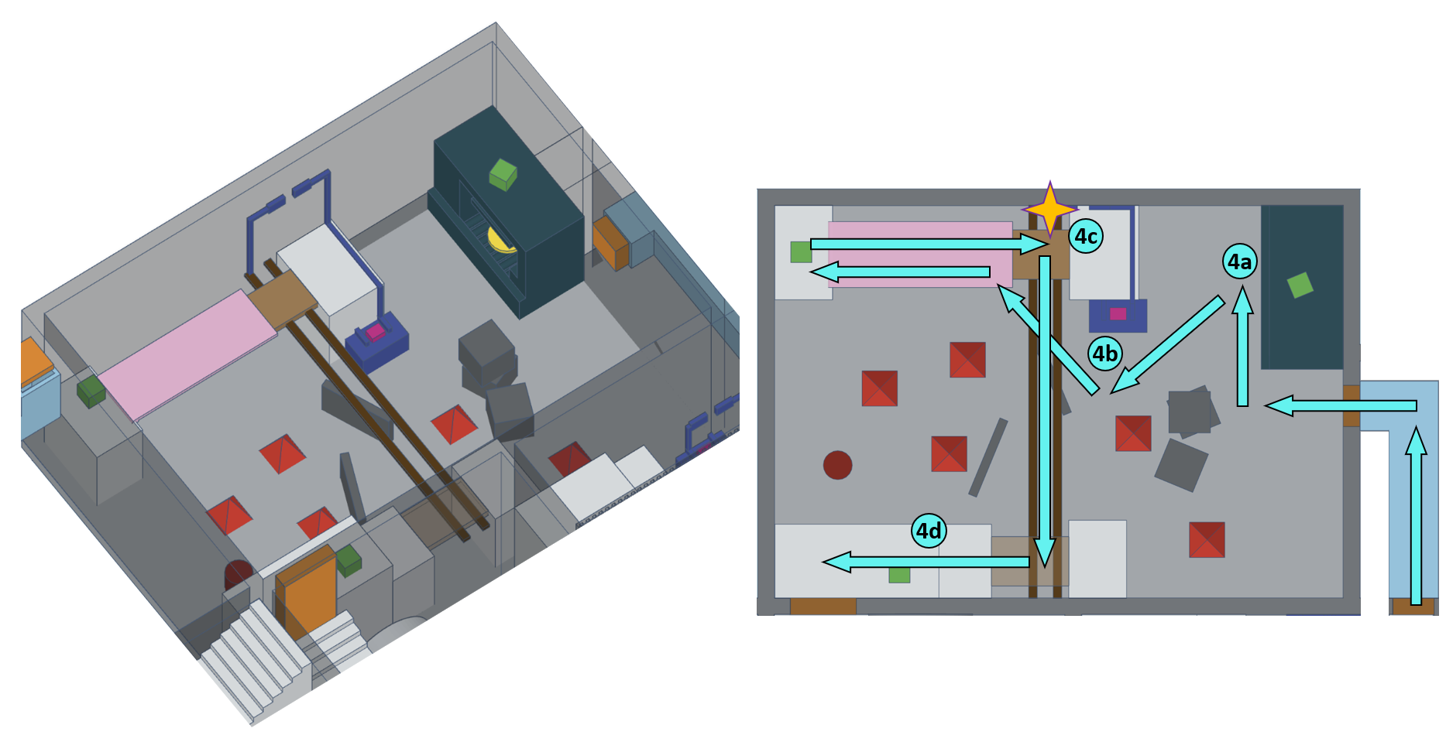
Figure 6: Section 3 Overview Map [1]
Map Label / Stage | Event Summary | Event Details | Wow?
4a | -Encounter | After the player enters the room, 5 Combine Soldiers will be spawned. Players can kill them with a Shotgun, or they can use the Gravity Gun to grab the Sawblade from the Sawblade Spawner to kill them.
4b | -Puzzle  -Reinforce: Sawblade Conductor | Use the Gravity Gun to shoot the Sawblade towards the place where the wire breaks. The Movable Platform will move, and the Physical Platform will fall due to the loss of Platform support. | Yes
4c | -Skill Challenge  -Reinforce: Sawblade Conductor | Use the Gravity Gun to grab the Sawblade connected to the wire to return the Movable Platform to its original position, walk to the Physical Platform, and jump to the Movable Platform.
4d | -Puzzle  -Reinforce: Sawblade Conductor | Re-shoot the Sawblade to the disconnected wire, activate the Platform to send yourself to the high platform on the opposite side, and leave the room.

Section 4: Waterwheel Engine Room & Cooling Room
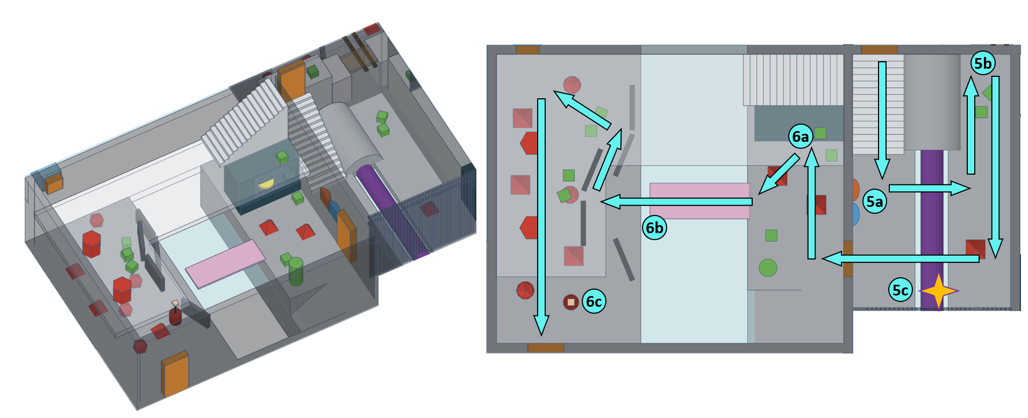
Figure 7: Section 4 Overview Map [1]
Map Label / Stage | Event Summary | Event Details | Wow?
5a | -Supply | After the player enters the room, 1 Combine Soldiers will be spawned. Kill him and use the Charger to restore power and health.
5b | -Supply | (Optional) Go behind the waterwheel engine to get more supplies.
5c | -Show Next Goal | Seeing the waterwheel outside through the guardrail, the player knows the next target to reach. | Yes
6a | -Encounter | After the player enters the room, 2 Combine Soldiers will be spawned next to the door, 3 Combine Soldiers and 4 Manhacks will be spawned on the other side of the cooling pool, 2 Combine Elite will be spawned on the higher floor. Players cannot damage Combine Elites at this time due to Blockers. Players can kill other enemies with a Shotgun, or they can use the Gravity Gun to grab the Sawblade from the Sawblade Spawner to kill them.
6b | -Puzzle  -Reinforce: Sawblade Blocker | Players need to use Physical Platforms to cross the cooling pool, but the Platforms are not long enough and cannot float on the water. Therefore, the player needs to shoot the Sawblade to the opposite shore as a support so that the Physical Platform will not fall into the water. Cross the Platform and exit the room.
6c | -Encounter | (Optional) Use a Sawblade to cut off the rope connecting the Explosive Barrel and let it fall and explode to kill a large number of enemies.

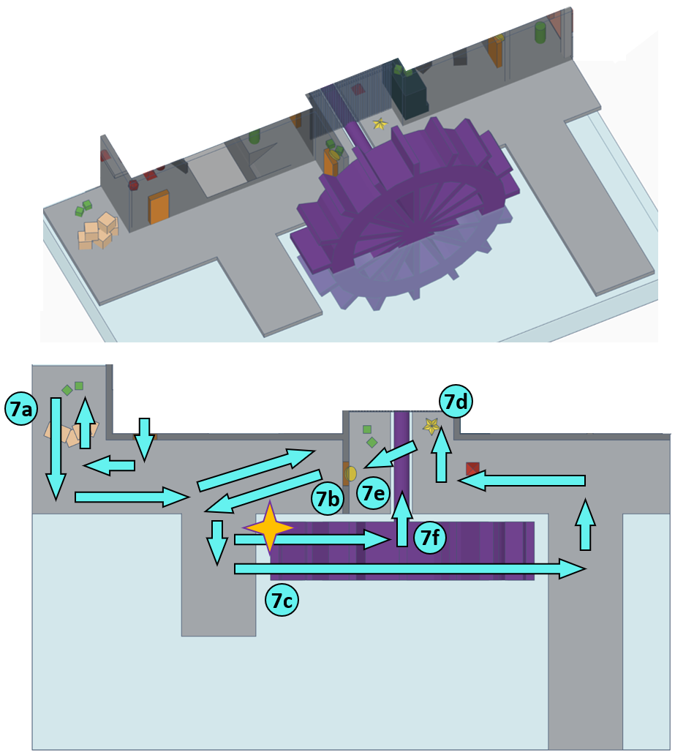
Section 5: Pier & Water Wheel
Figure 8: Section 5 Overview Map [1]
Map Label / Stage | Event Summary | Event Details | Wow?
7a | -Supply | (Optional) After entering the room, turn right and break the breakable boxes to pick up additional supplies.
7b | -Show Tips | The player found that the door in front could not be opened, but the supplies and enemies behind the door could be seen through the guardrail, so the player began to look for a way to reach behind the door.
7c | -Skill Challenge  -Reinforce: Sawblade Platform | The player returns to the waterwheel, finds the mark on the waterwheel, and tries to shoot the Sawblade to the mark. The player can stand on the Sawblade and uses the waterwheel to transport himself to the opposite side. | Yes
7d | -Secret | Kill the enemy and find the secret.
7e | -Puzzle  -Reinforce: Sawblade Blocker | Use the Gravity Gun to grab the Sawblade blocking the door and make the door open.
7f | -Skill Challenge  -Reinforce: Sawblade Platform | Gao back to the waterwheel. Stand on the Sawblade on the waterwheel again and jump to the balcony of the second floor as the waterwheel transports you to the highest point.

Section 6: Power Supply Room & 2nd Floor of Cooling Room
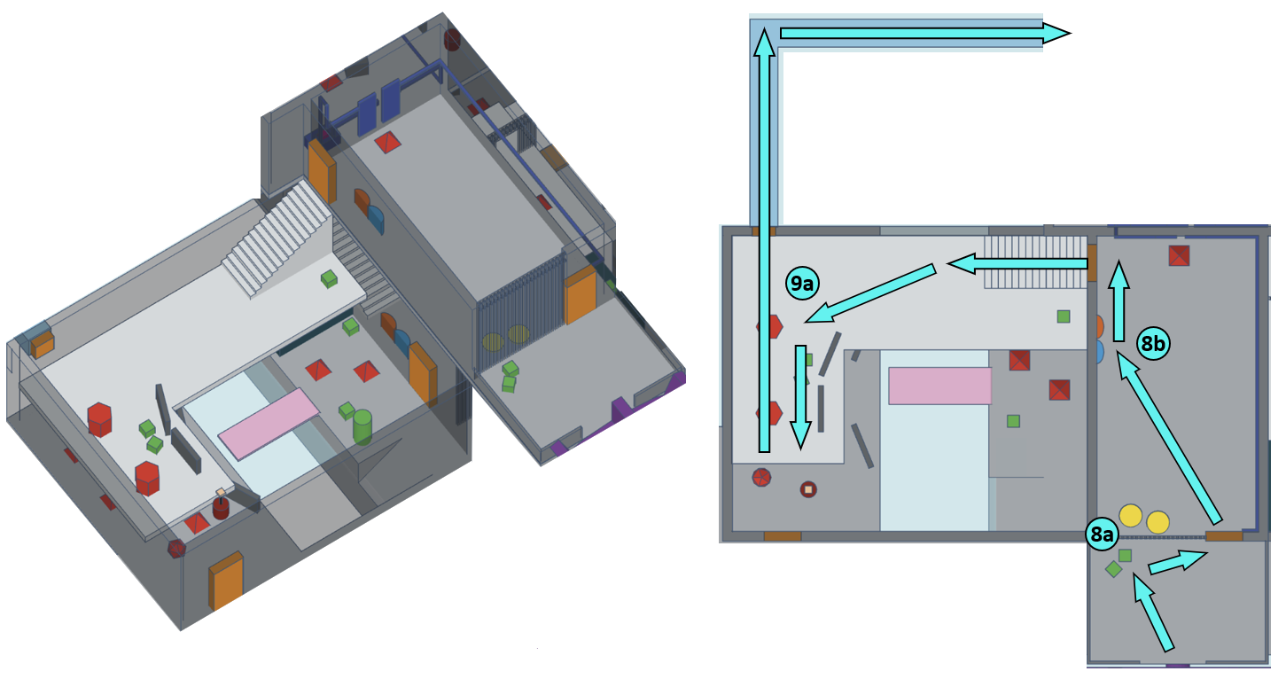
Figure 9: Section 6 Overview Map [1]
Map Label / Stage | Event Summary | Event Details | Wow?
8a | -Puzzle  -Reinforce: Sawblade Conductor | The player finds that the door ahead is locked. Through the guardrail, the player can find that the wire connecting the door is broken. A Combine Soldier is checking the circuit. There are two Sawblades on the ground in the room. So, the player uses the Gravity Gun to shoot the Sawblade towards the disconnected circuit and kill the enemy at the same time. Door restores power and opens automatically.
8b | -Supply | Enter the room and restore power and health with charger.
9a | -Encounter  -Reinforce: Sawblade Platform  -Skill Challenge | Enter the higher floor of the cooling room. Kill the two Combine Elite. Use the Gravity Gun to shoot the Sawblade to the wall under the entrance of pipe. Use the Sawblade as a Platform to enter the pipe.

Section 7: Cutting Room
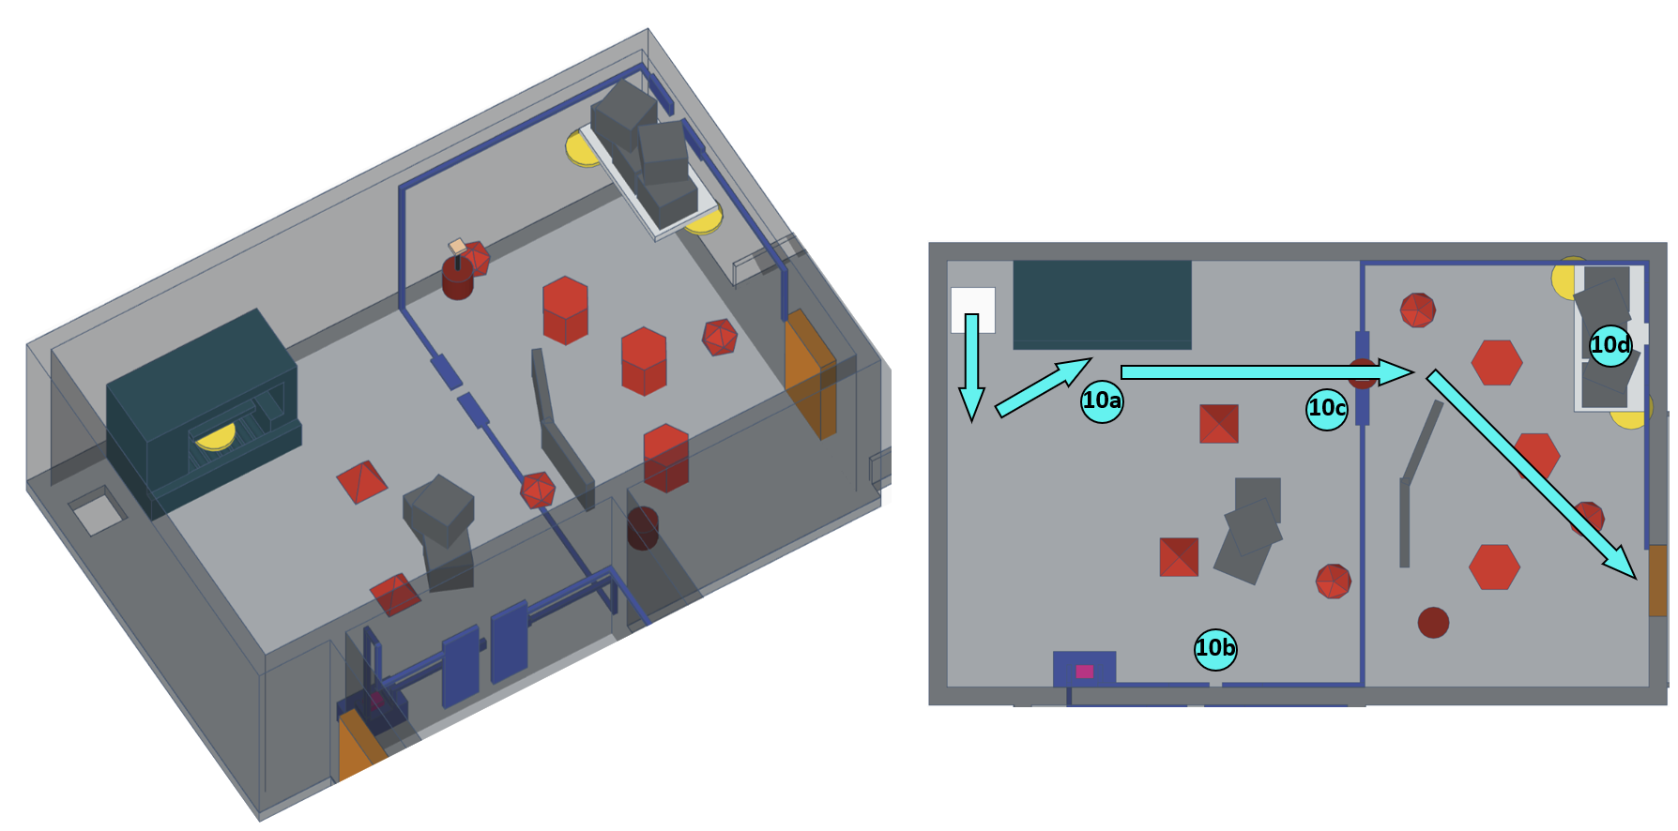
Figure 10: Section 7 Overview Map [1]
Map Label / Stage | Event Summary | Event Details | Wow?
10a | -Encounter | After the player enters the room, 2 Combine Soldiers, 3 Combine Elites and 3 Manhacks will be spawned. Players can kill them with a Shotgun, or they can use the Gravity Gun to grab the Sawblade from the Sawblade Spawner to kill them.
10b | -Puzzle  -Reinforce: Sawblade Conductor | Shoot the Sawblades to the two broken wires and make them connected.
10c | -Encounter | (Optional) Players can use a Sawblade to cut off the rope connecting the Explosive Barrel and let it fall and explode to kill a large number of enemies.
10d | -Puzzle  -Reinforce: Sawblade Blocker | The player discovers that there is another broken wire that has not been connected, but it is blocked by a pile of boxes. Players need to use the Gravity Gun to grab the Sawblades supporting the box and let the box fall, then use the Sawblade to shoot to the broken wire to restore power to the door. Open the door and enter the balcony.

Section 8: Terrace & Exit Elevator
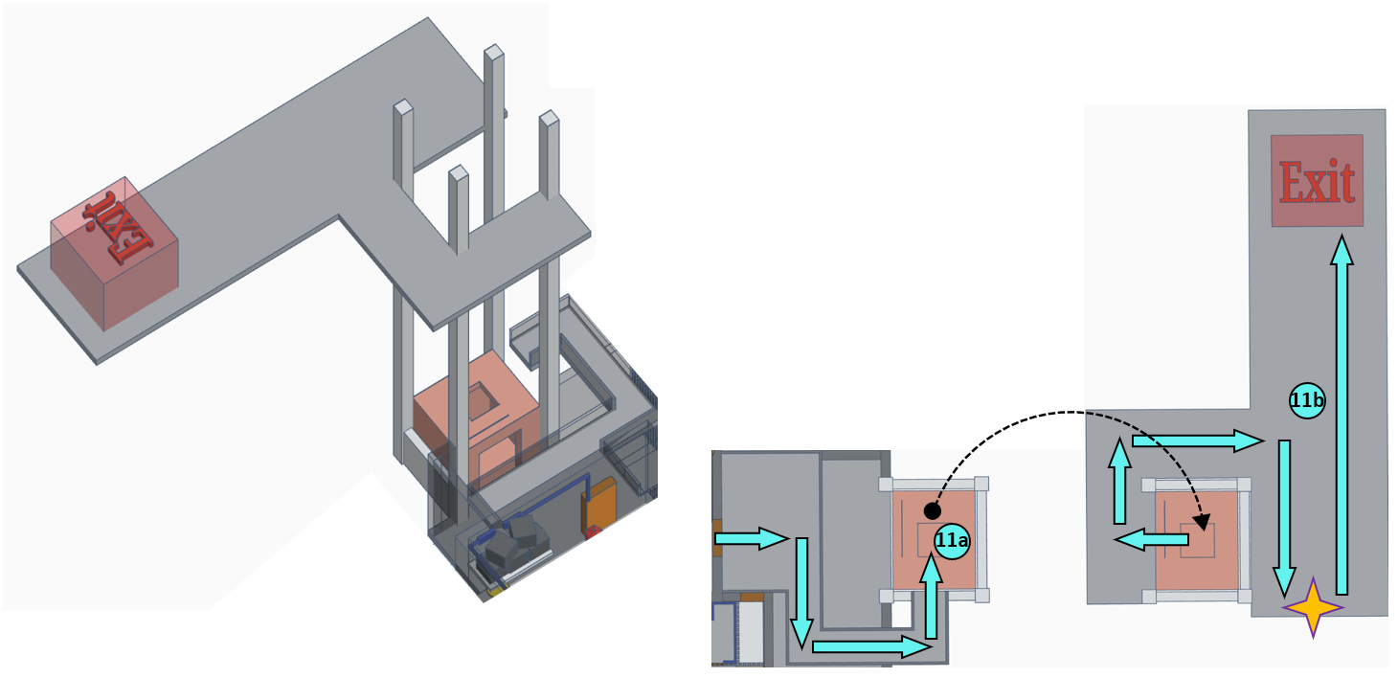
Figure 11: Section 8 Overview Map [1]
Map Label / Stage | Event Summary | Event Details | Wow?
11a | -Ending | Follow the balcony passage to the top of the elevator and jump into it. Start the elevator and reach the upper floor.
11b | -Ending | The player walks to the edge of the cliff and looks back at where he comes and recalls this wonderful adventure. Then the player turns around and walks towards the finish exit. | Yes

Skill Progression Chart
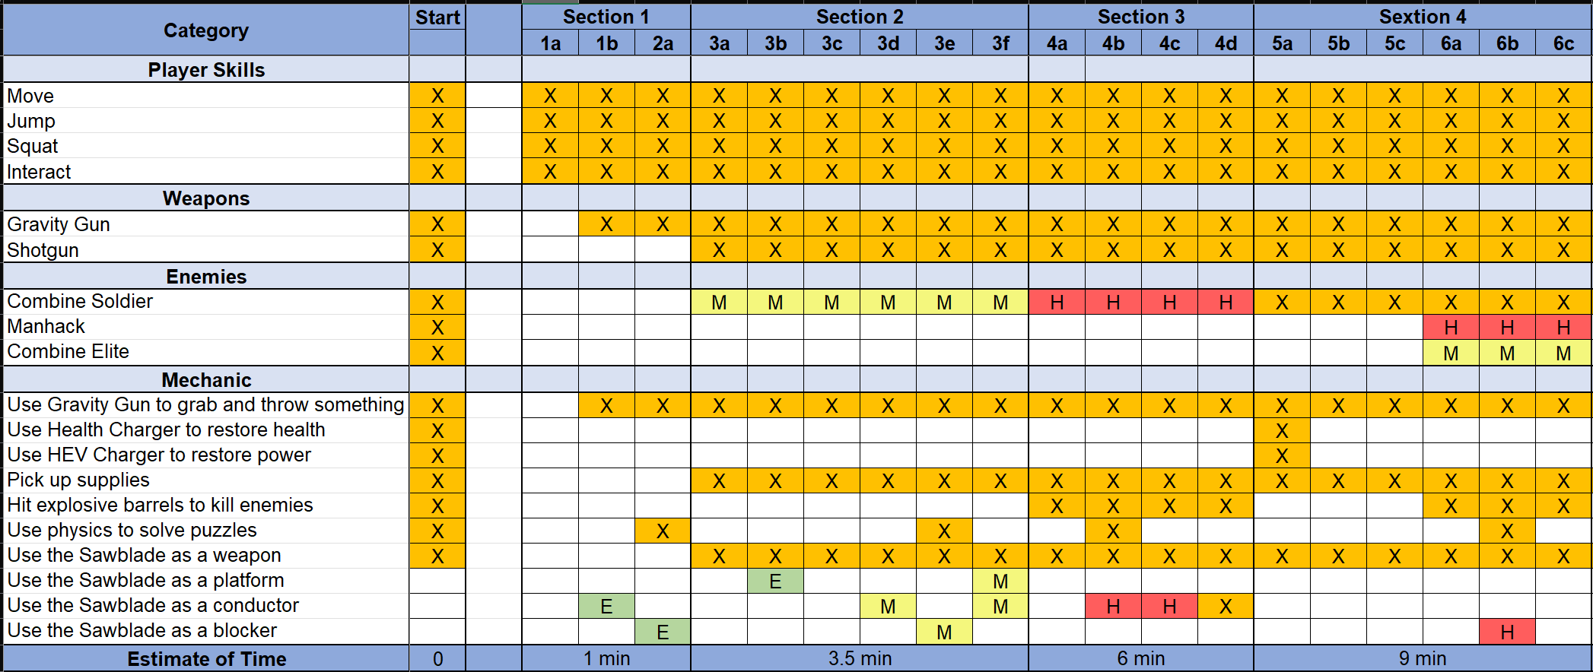
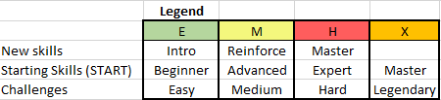
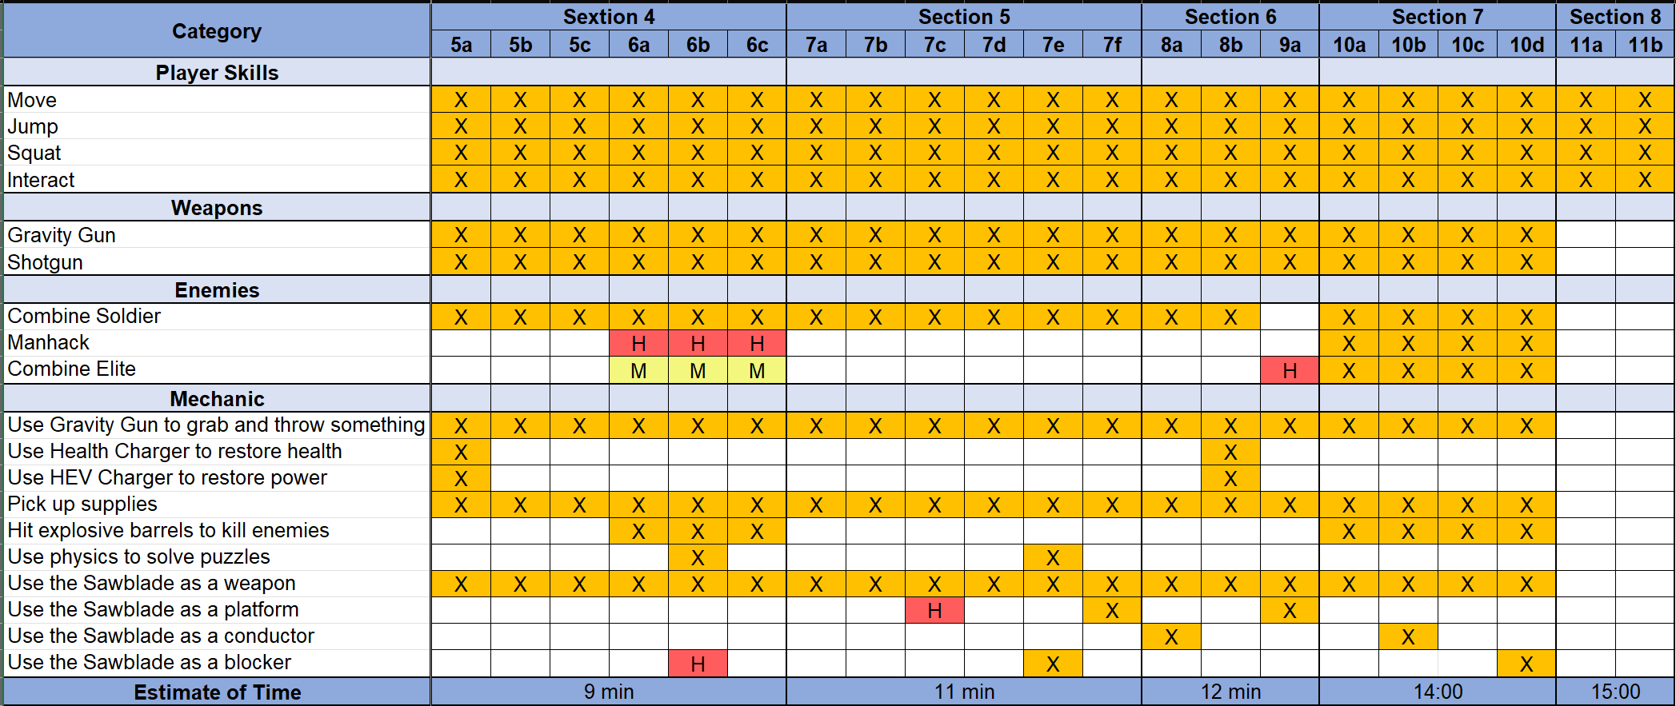
Figure 12: Skill Progression Chart

Aesthetic References
The level takes place in the "Highway 17" chapter, so overall the visual theme of the level should match the art style of Highway 17 and its surrounding areas.
In terms of details, the interior theme of the level is in line with the modern factory style. Each room has its own unique elements. For example, the theme of the Heating Room is fire, the theme of the Cooling Room is water, etc.
The outdoor theme of the level uses the pier as a reference. Waterwheel and industrial elevators will be representative of the outdoor landmarks of the level.

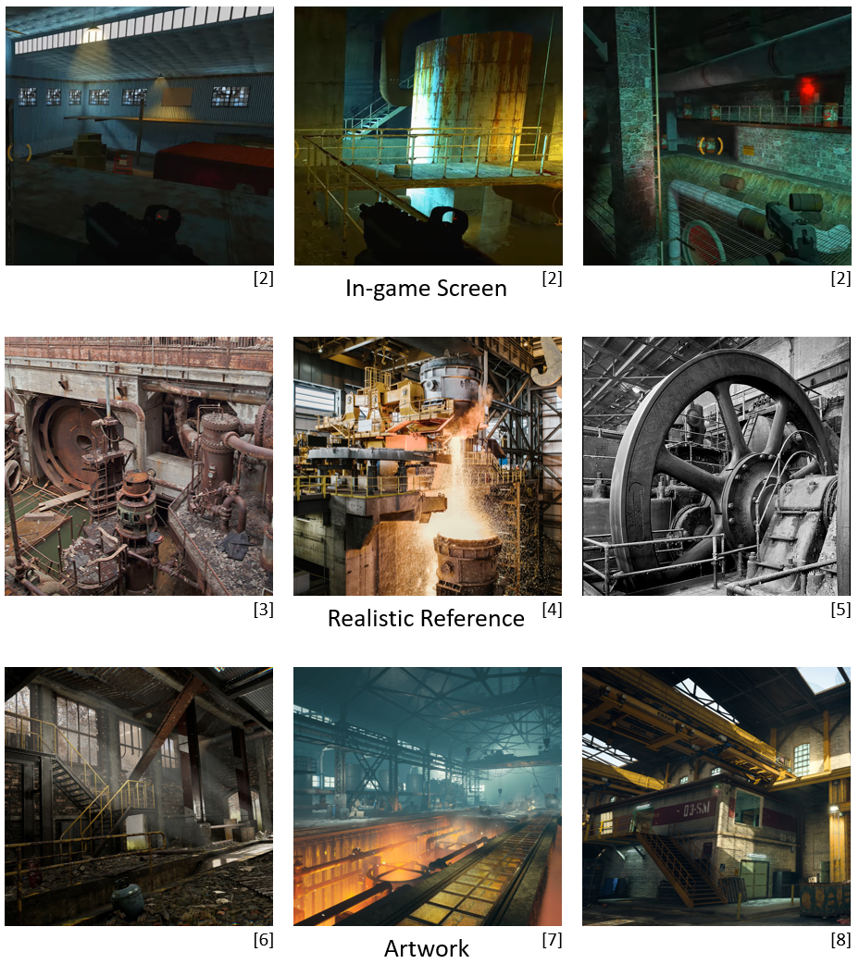
Visual Theme 1: Interior Theme

Figure 13: Contact Sheet for Interior Theme [2, 3, 4, 5, 6, 7, 8]

Visual Theme 2: Exterior Theme
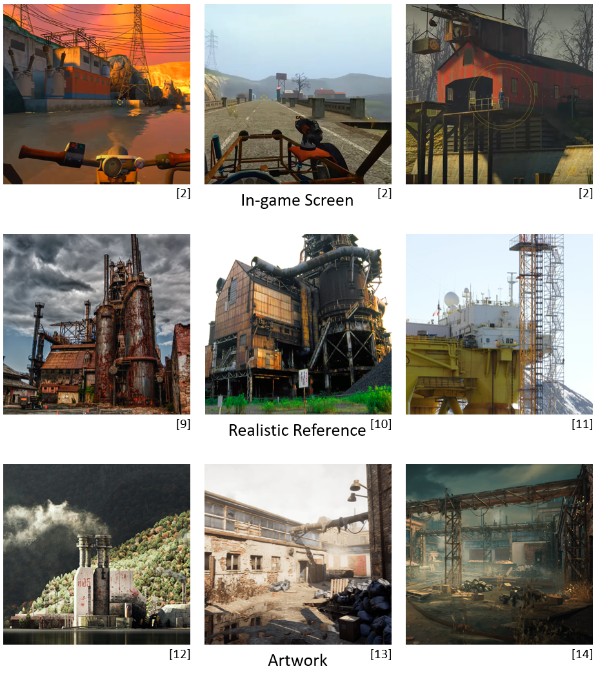
Figure 14: Contact Sheet for Exterior Theme [2, 9, 10, 11, 12, 13, 14]

References
[Cover Image] “135/365 Half Life 2”, Flickr, Flickr.com. [Online] Available at: https://www.flickr.com/photos/22466737@N00/5377783066/. [Accessed: 10/30/2023]
[1] Wang, Wilbur, Screenshot from Tinkercad, Tinkercad, Tinkercad.com. [Accessed: 10/30/2023]
[2] Wang, Wilbur, Screenshot from Half-Life 2, Valve, 2004. [Accessed: 10/30/2023]
[3] “Mystic Places”, Pinterest, Pinterest.com. [Online] Available at: https://www.pinterest.com/pin/272467846184715168/. [Accessed: 10/30/2023]
[4] “Enter the 9,000-Degree Hell That Melts 2 Million Tons of Steel a Year”, Pinterest, Pinterest.com. [Online] Available at: https://www.pinterest.com/pin/945333778012247615/. [Accessed: 10/30/2023]
[5] “Steel Mill”, Pinterest, Pinterest.com. [Online] Available at: https://www.pinterest.com/pin/485755509818841206/. [Accessed: 10/30/2023]
[6] “Abandoned factory Unreal 4”, ArtStation, Artstation.com. [Online] Available at: https://www.artstation.com/artwork/ybgmNK. [Accessed: 10/30/2023]
[7] “Factory 3D environment”, ArtStation, Artstation.com. [Online] Available at: https://www.artstation.com/artwork/6a4VO6. [Accessed: 10/30/2023]
[8] “COD Modern Warfare - Mialstor Tank Factory”, ArtStation, Artstation.com. [Online] Available at: https://www.artstation.com/artwork/Kry54y. [Accessed: 10/30/2023]
[9] “Steel”, Pinterest, Pinterest.com. [Online] Available at: https://www.pinterest.com/pin/854346991825084071/. [Accessed: 10/30/2023]
[10] “1.61”, Pinterest, Pinterest.com. [Online] Available at: https://www.pinterest.com/pin/563018682552661/. [Accessed: 10/30/2023]
[11] “Polar Pioneer”, Pinterest, Pinterest.com. [Online] Available at: https://www.pinterest.com/pin/13088655145242458/. [Accessed: 10/30/2023]
[12] “Lake 005 (24 hour challenge #2)”, ArtStation, Artstation.com. [Online] Available at: https://www.artstation.com/artwork/qAA2E2. [Accessed: 10/30/2023]
[13] “Abandoned Factory | Relight”, ArtStation, Artstation.com. [Online] Available at: https://www.artstation.com/artwork/vJVYBa. [Accessed: 10/30/2023]
[14] “Abandoned Factory. Birmingham”, ArtStation, Artstation.com. [Online] Available at: https://www.artstation.com/artwork/nYZOOe. [Accessed: 10/30/2023]

Appendices

Appendix A: New Skills / Gameplay Mechanics

Use the Sawblade as a Platform
- Description
  - Added a collision body to the Sawblade so the player can stand on it. Players can shoot Sawblades into walls to create a simple platform, and players can jump onto the Sawblades to reach higher locations.
- Conveyance & Feedback
  - When the player meets this mechanic for the first time, there will be a Sawblade embedded in the wall under the high platform in the scene, prompting the player to jump to it.
  - Special material like cork will be used where players are required to use this mechanic.

Use the Sawblade as a Conductor
- Description
  - Broken wires will appear in the scene, and players need to use a gravity gun to shoot the Sawblade to the wires where is broken to restore power. This mechanic relies on collision detection. When the area before the broken wire is detected to overlap with the Sawblade, the mechanism will take effect.
- Conveyance & Feedback
  - There will be spark particle effects at the broken wire reminding players to use this mechanic.
  - When the player successfully completes the operation of connecting the wire, the indicator light will turn green, and the Sawblade will also change color to give the player feedback.

Use the Sawblade as a Blocker
- Description
  - The Sawblade can block objects that have physical properties or can move, such as doors.
- Conveyance & Feedback
  - The first time the player meets this mechanic is when they encounter a door blocked by a Sawblade. The player must use the Gravity Gun to grab the Sawblade to open the door. Forced teaching will make players remember this mechanism deeply.
  - Special stickers will be used where players are required to use this mechanic.

Appendix B: Context Detail

General Context
- How to fit the main game
  - Challenge: This level takes place in the "Highway 17" chapter of the main game. At this time, the player has just completed the Ravenholm chapter and learned how to use the Sawblade. This level is designed to expand the functionality of Sawblade, which fits the challenge pacing of the main game.
  - Aesthetic: The overall art style of the level will match the style of Highway 17 and its surrounding facilities.
- This level takes place in the "Highway 17" chapter of the main game. It can be regarded as the "what if" story of the “Highway 17" chapter.
- This is a stand-alone mission.

Backstory
When Freeman was driving on Highway 17, he discovered that the road ahead had collapsed. He also found that the collapsed road was connected by two elevators, and underneath the elevator was a saw blade factory. In order to get over the collapsed road, Freeman had to take a detour into the factory and engaged Combine enemies.

Aftermath
Freeman successfully reached the other side of the collapsed road, but he was unable to transport the vehicle over. Fortunately, it was not far from the mine, and he successfully walked to the mine.

Appendix C: Character Descriptions (N/A)

NPC 1: N/A
Description | N/A
Background | N/A
Goals/Motivation | N/A
Personality/Archetype | N/A
Relationships | N/A

NPC 2: N/A
Description | N/A
Background | N/A
Goals/Motivation | N/A
Personality/Archetype | N/A
Relationships | N/A

Appendix D: Dialog Flow (N/A)

NPC 1: N/A

Appendix E: Development Risks
Map Label | Description/Mitigation | Type | Priority
1b | Difficult to tell whether the Sawblade successfully triggered the action of the conductor. | Script | High
1b | Not sure how effective using spark particle effects helps conveyance. | Visual | Medium
2a | Difficult to control the blocking effect of the Sawblade on non-physical objects. | Script | High
3a | Not sure if the Sawblade Spawner has an unlimited supply of Sawblades. If so, not sure what impact it will have on game stability. | Script | Medium
6b | Difficult to control whether the Sawblade can withstand the impact of the physical platform | Script | High
7c, 7f | Difficult to achieve the effect of the Sawblade following the waterwheel rotation | Script | High

Appendix F: Key Asset Needs
Description | Type | Priority
Highway | Prop | High
Elevator | Prop | High
Door (Wooden & Iron) | Prop | High
Sawblade | Prop | High
Battery | Prop | High
Electric Wire | Prop | High
Obstacle | Prop | Medium
Platform | Prop | High
Pipeline | Prop | High
Explosive Barrel | Prop | Medium
Boxes (Wooden & Iron) | Prop | High
Supplies | Prop | High
Charger | Prop | High
Light | Prop | High
Waterwheel Engine | Prop | Medium
Waterwheel | Mesh | High
Sawblade Spawner | Mesh | High
Power Supply Table | Mesh | Medium
Physical Platform (Wooden & Metal) | Mesh | Medium
Platform Track | Mesh | Medium
Guardrail | Mesh | Medium
Skybox | Texture | High
Water | Texture | High
Cork | Texture | High
Wooden Plank | Texture | Medium
Metal Plate | Texture | Medium
Metal Net | Texture | Medium
Metal Wall | Texture | Medium
Lime Wall | Texture | Medium
Lime Floor | Texture | Medium
Lime Ceiling | Texture | Medium
Cement Floor | Texture | Medium
Red Brick Wall | Texture | Medium
Spark | Particle | High
Electric Arc | Particle | Medium
Dust | Particle | Low
Smog | Particle | Low
Peeled Paint | Decal | High
Combine Soldier | NPC | High
Combine Elite | NPC | High
Manhack | NPC | High

