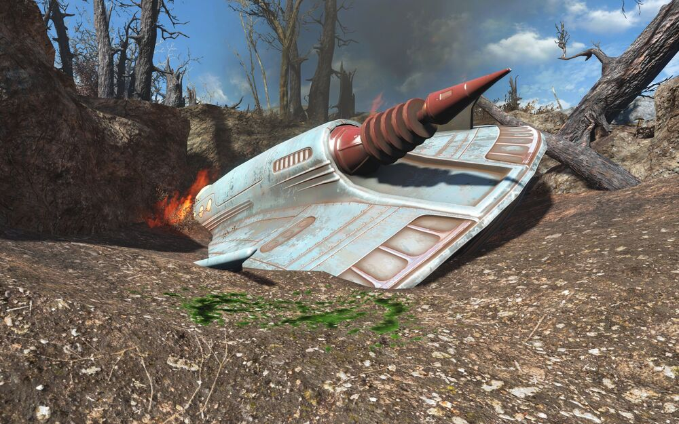
[Cover Image]

Fallout 4: District 8
  - Version 1.0
Designer: | Wilbur Wang
Document Date: | 2/19/2024
Intended Level Delivery Date: | 4/29/2024

Document Revisions Table
Version | Description | Requestor | Date
1.0 | Initial Document | Professor Ouellette | 2/19/2024

Table of Contents
Table of Contents 2
Table of Figures 5
Level Summary 6
Quick Summary 6
Level Feature Overview 6
Development Schedule 8
Level Overview 9
Overview Map 9
Narrative Flow Chart 11
Level Details 12
Detail Maps 12
Section 1 Red Rocket 12
Section 2 District 8 14
Section 3 Assembly Room 18
Section 4 Central Control Room 1F 20
Section 5 Quality Inspection Room 22
Section 6 Meeting Room 24
Section 7 Factory Hall 26
Section 8 Central Control Room 2F 28
Section 9 Power Supply Room 29
Section 10 Archives 31
Section 11 Factory Hall 33
Section 12 Central Control Room 2F 35
Section 13 Central Control Room 3F 36
Section 14 Central Control Room 1F 38
Section 15 Factory Hall 39
Section 16 District 8 41
Skill Progression Chart 43
Aesthetic References 44
<Visual Theme 1 (replace with meaningful name of theme)> 44
<Visual Theme 2 (replace with meaningful name of theme)> 45
References 46
Appendices 47
Appendix A: New Skills / Gameplay Mechanics 47
<Mechanic A> 47
<Mechanic B> 47
Appendix B: Context Detail 48
General Context 48
Backstory 48
Aftermath 48
Appendix C: Character Descriptions 49
NPC 1: <character name> 49
NPC 2: <character name> 49
Appendix D: Dialog Flow 50
NPC 1: <character name> 50
Appendix E: Development Risks 52
Appendix F: Key Asset Needs 53

Table of Figures

Figure 1: Overview Map [1] 9
Figure 2: Red Rocket Overview Map [1] 11
Figure 3: District 8 Overview Map [1] 13
Figure 4: Assembly Room Overview Map [1] 17
Figure 5: Central Contral Room 1F Overview Map [1] 19
Figure 6: Quality Inspection Room Overview Map [1] 21
Figure 7: Meeting Room Overview Map [1] 23
Figure 8: Factory Hall Overview Map [1] 25
Figure 9: Central Contral Room 2F Overview Map [1] 27
Figure 10: Power Supply Room Overview Map [1] 28
Figure 11: Archives Overview Map [1] 30
Figure 12: Factory Hall Overview Map [1] 32
Figure 13: Central Contral Room 2F Overview Map [1] 34
Figure 14: Central Contral Room 3F Overview Map [1] 35
Figure 15: Central Contral Room 1F Overview Map [1] 37
Figure 16: Factory Hall Overview Map [1] 38
Figure 17: District 8 Overview Map [1] 40
Figure 18: Skill Progression Chart 42
Figure 19: Contact Sheet for Visual Theme 1 [#,#,#] 43
Figure 20: Contact Sheet for Visual Theme 2 [#,#,#] 44
Figure 21: Dialog: Character 1, Stage 0 49
Figure 22: Dialog: Character 1, Stage 10 49
Figure 23: Dialog: Character 1, Stage 30 50
Figure 24: Dialog: Character 1, Stage 100 50

Level Summary

Quick Summary
District 8 is a Fallout 4 single-player optional side quest serving as a supplement about aliens. Players can accept this quest near the Red Rocket after completing the main story quest "Reunions". The story takes place in a small factory town called "District 8" and tells the story of players going there to investigate a crashed UFO.
This quest features a variety of gameplay styles, including melee, ranged, stealth, charisma check, lockpicking, pickpocketing and hacking. Also, this quest provides players with a unique weapon, the Alien Transmogrifier, which can transform human targets into aliens. Go and use these skills and equipment to go to the factory where the UFO crashed to find out the truth about a series of events!

Level Feature Overview
Category | Sub-Category | Feature List
Gameplay Themes | Combat | - Target Transforming (Use Alien Transmogrifier to transform human targets into aliens.)  - Fight with aliens with different weapons.  - Alien Blaster – Med  - Combat Shotgun – Short  - Combat Rifle – Med to Long  - Machete – Melee
 | Exploration | - Stealth – The level layout provides players with multiple stealth routes.  - Charism Check – Players can avoid certain combats using charisma check.
Player | Player Weapons | - Alien Transmogrifier (Unique) – Med  - 10 mm Pistol – Short  - [Optional] Alien Blaster – Med  - [Optional] Combat Shotgun – Short  - [Optional] Combat Rifle – Med to Long  - [Optional] Machete – Melee
 | Player Skills/Abilities | - Charisma Check  - Lockpicking  - Pickpocketing  - Hacking  - Stealth  - Transfer targets to aliens (with the unique weapon)
AI | Enemies | - Aliens (with different weapons)  - Alien Blaster – Med  - Combat Shotgun – Short  - Combat Rifle – Med to Long  - Machete – Melee  - Raiders (with different weapons)  - Alien Blaster – Med  - Combat Shotgun – Short  - Combat Rifle – Med to Long  - Machete – Melee  - NPCs (Potential Enemy)  - Mr. X (A customized alien with enhanced health and attack damage.)  - Hansen (Boss Raider)  - Thor (Boss Raider)
 | Friendlies | - Mr. X – Main quest giver. A mysterious man in a space suit, whose identity is the leader of the aliens. Will show his face at the end of the story. May change faction based on player’s choice.  - Hansen – A human male who calls himself the mayor. May change faction based on player’s choice.  - E0037 – One of the few aliens captured by humans who can communicate in human language.  - Thor – A burly human female soldier in charge of guarding the weapons cache. May change faction based on player’s choice.  - Paul – Side quest giver. A male human resident whose friend has not returned for a long time since going to the factory. He will ask the player for help to go to the factory to find his friends.
Challenges | Obstacles/Hazards | - Locked Door (Requires lockpicking or terminal hacking to open)  - Chained Door (Can only pass through from one side)
 | New/Unique Gameplay | - Target Transforming – Players can use the unique weapon Alien Transmogrifier to transform human targets into aliens and make them hostile to other raiders and aliens within 60 seconds.
Context | Location in Game | - The quest giver is near the Red Rocket.  - The main space of this level is standalone and can be accessed by talking with the quest giver near the Red Rocket and interacting the vehicle beside him.
 | Challenge Fit in Game | - This quest can only be accepted after the player has completed Act I. At this point players are around level 10 to 15 and have some understanding of charisma checks, stealth, lockpicking, hacking, pickpocketing, and different melee and ranged weapons.  - The only unique mechanic Target Transforming is obvious to convey, and the others are all gameplays that appear in the main game.
 | Narrative Fit | - Aliens are a kind of creature that appears in the main game, but there is few information for aliens. This quest is a supplement to the aliens’ information.  - This is an optional side quest separate from the main story and is set right after the end of Act I.
 | Basic Backstory / Results Info | - To become the mayor and achieve his own goals, Hansen transformed those who opposed him into aliens.
Aesthetics | Major Visual Themes | - High Level Theme – Wasteland Style  - Exterior – Hardware Town  - Interior – Longneck Lukowski's Cannery
 | Setting/Mood | - Time – Early Evening  - Weather – Cloudy  - Mood – Gloomy

Development Schedule
Milestone | Date
LDD | 2/19/2024
Whitebox | 3/4/2024
Initial Gameplay | 3/25/2024
Gameplay Complete | 4/15/2024
Aesthetics | 4/22/2024
Launch | 4/29/2024

Level Overview

Overview Map
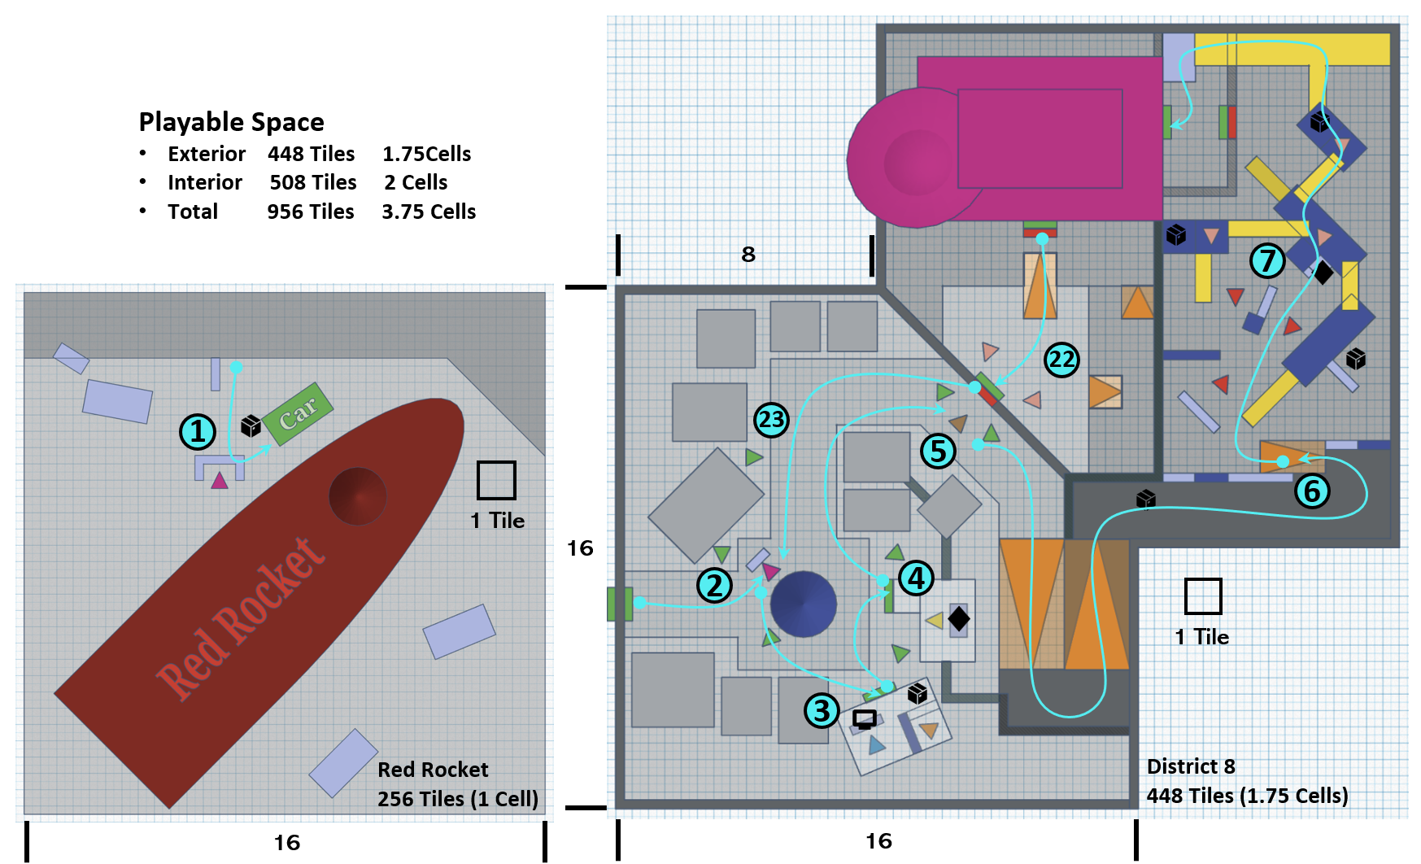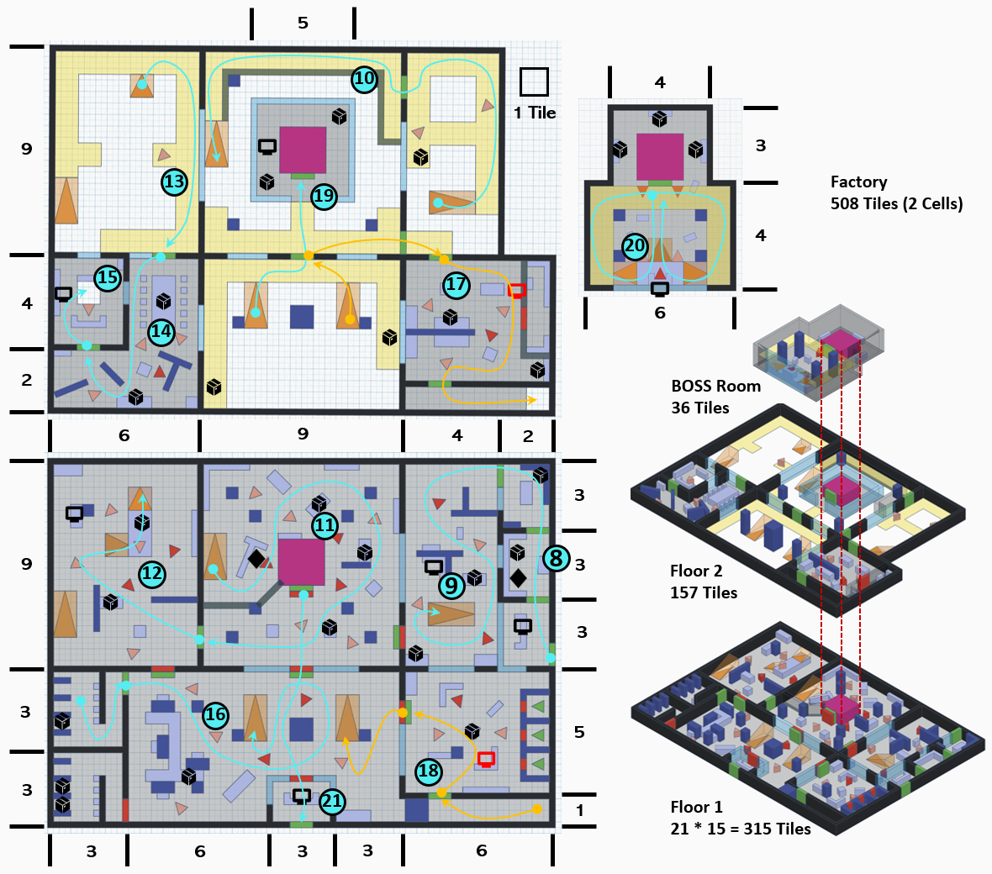
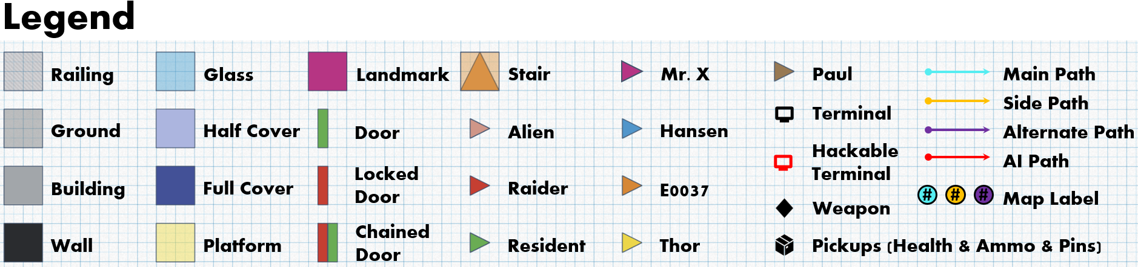
Figure 1: Overview Map [1]
Map Label | Gameplay Summary
1 | Find and talk to the NPC Mr. X near the Red Rocket, know about the basic information of UFO, and accept the quest to go to District 8. [Main quest accepted]
2 | Take Mr. X’s vehicle to District 8, talk to him at the fountain to learn about the conflicts between residents and aliens, and learn that mayor Hansen is in a nearby building.
3 | Find and talk to the mayor Hansen and know that many residents in the town who have been to the factory have disappeared one after another. Hansen wants you to go to the factory to investigate.  Talk to the alien in the cage next to Hansen and learn that there is a unique weapon hidden by Hansen in the weapon cache.
4 | Go to the weapon cache and defeat guard Thor. Then get the unique weapon Alien Transmogrifier.
5 | Find Paul at the gate of the factory and talk to him and learn that his friends went to the factory and did not return for several days. He wants you to help find them. [Side quest accept]
6 | Reach the inner courtyard of the factory through the hillside on the edge of town and get a preview of the combat space and the side entrance of the factory.
7 | Encounter a battle with Aliens and Raiders, take them down and enter the factory through the side door.
8 | Use the terminal to get extra information at the counter. Gather supplies and a ranged weapon from the locker room and storage room.
9 | Enter the assembly room. Encounter a battle with Aliens and Raiders, take them down. Use the terminal to get extra information.
10 | Use the platform on the second floor to reach the central control room.
11 | Follow the stairs to the first floor of the central control room and get a melee weapon. Encounter a battle with Aliens and Raiders, take them down.
12 | Enter the quality inspection room. Encounter a battle with Aliens and Raiders, take them down. Use the terminal to get extra information.
13 | Use the platform on the second floor to reach the meeting room.
14 | Encounter a battle with Aliens and Raiders, take them down.
15 | Enter the private room of the meeting room. Use the terminal to get extra information. Fall down the broken floor to reach the restroom at the first floor.
16 | Leave the restroom and reach the hall. Seeing that Mr. X is at the central control room 3F. Encounter a battle with Aliens and Raiders, take them down. Open the shortcut door connected to the central control room.
17 | Use the platform on the second floor to reach the power supply room. Encounter a battle with Aliens and Raiders, take them down. Enter the corridor, go to the end of the corridor, and drop from the broken floor to the first-floor corridor.
18 | Enter the archives. Encounter a battle with Aliens and Raiders, take them down. Hack the terminal to unlock the cage door and free Paul's friends. [Side quest completed]
19 | Leave the archives. Use the platform on the second floor to reach the elevator to the central control room. Use the terminal to get extra information.
20 | Use the elevator to reach central control room 3F and talk to Mr. X. He tells you the final information and reveals his identity. Based on the information obtained, you need to make a choice to support Hansen or Mr. X.
21 | [Choose to support Hansen] Fight with Mr. X and his entourage. Use the terminal to open the gate of the factory.
22 | [Choose to support Mr. X] Mr. X will open the gate of the factory for you. You will fight with Hansen and his entourage in the front yard of the factory.
23 | Back to the town and report to the leader who finally survived. [Main quest completed]

Narrative Flow Chart

Level Details

Detail Maps

Section 1 Red Rocket
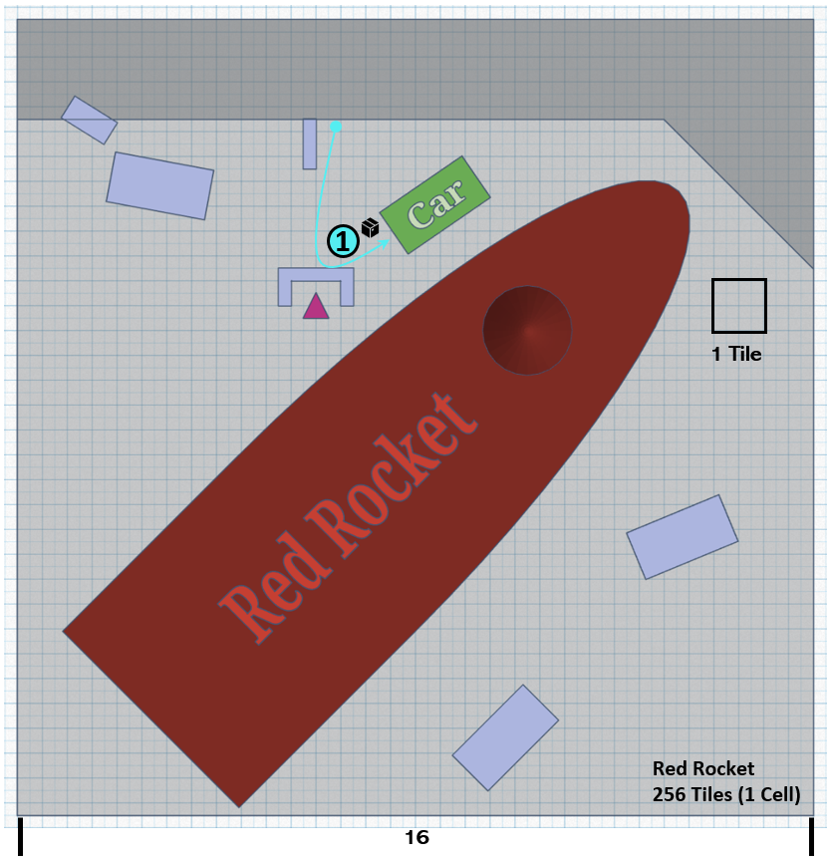
Figure 2: Red Rocket Overview Map [1]
Map Label / Stage | Event Summary | Event Details
1 | [Main quest start] Find Mr. X at Red Rocket and accept the main quest. | Key Information:  - A UFO crashed above the factory in District 8.  - He said he likes aliens very much.  - He plans to leave for District 8 and asks if you want to go with him.  - If you keep asking, you can get more information about Aliens and District 8.  - Aliens are not hostile to humans.  - District 8 was not originally called this name.  - District 8 was originally a town composed of a group of Raiders.  Conveyance:  - He was wearing a spacesuit that covered his face.  - He's selling mini-UFO toys from a cart.

Section 2 District 8
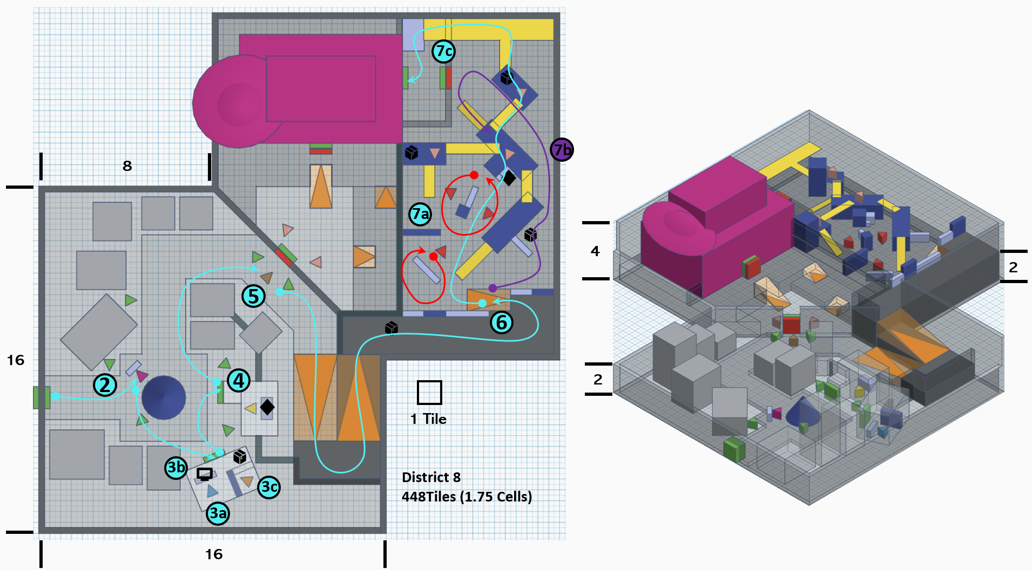
Figure 3: District 8 Overview Map [1]
Map Label / Stage | Event Summary | Event Details
2 | Narrative Beats. Enter the District 8 and talk to Mr. X. | Key Information:  - The residents have just finished killing an alien that have been breaking into the town.  - He's angry about the alien's death.  - He tells the player the name and location of the mayor.  Conveyance:  - Alien corpses remain on the ground.  - Some alien bodies were hung on street signs.  - Landmark: A huge UFO crashed on the factory roof in the distance.
3a | Narrative Beats. Find and talk to mayor Hansen. | Key Information:  - People are missing one after another in towns.  - Aliens and residents compete for survival resources, which results in the two camps being in a constant state of hostility.  - He believes that aliens must be eradicated for the future of the residents.  - The factory gate is locked, so you have to find another way.  - Hansen will walk outside the room after you finish the key conversation with him.  Conveyance:  - The building he is in is illuminated by streetlights.
3b | [Optional] Narrative Beats. Check Hansen’s terminal to get extra information. | Key Information:  - A notification telling Hansen that reverse engineering of an alien weapon was completed.  - A list of people.
3c | Narrative Beats. Talk to the captured alien E0037. | Key Information:  - This dialogue can be triggered actively by the player, or it can be forced to be triggered when the player is about to leave the room.  - He would only repeat the words "weapon coach" and "weapon".  Conveyance:  - His cage is set up in an obvious place and is illuminated by lights.
4 | Combat / Skill Challenge. Go to the weapon coach to get the unique weapon. | Challenge Goal:  - Find a way to get into the weapon coach and gain the unique weapon.  Key Information:  - Go to the weapons cache and talk to the guard Thor, she is preventing you from entering, you can choose:  - Fight with her to get the key.  - Use charisma check to let her open the door.  - Use pickpocketing to get the key.  - Enter the weapon cache and get the unique weapon Alien Transmogrifier.  - Leave the weapon cache and continue to go to the factory.  Conveyance:  - The color of the building is obviously different from other buildings and there is a road sign beside it.  - The unique weapon Alien Transmogrifier is in the most prominent place in the room.
5 | [Side quest start] Find and talk to Paul at the gate of the factory. | Key Information:  - His friends didn’t return for several days after going to the factory.  - He wants you to help to find them in the factory.  - The gate of the factory is locked inside but there is a way to the courtyard at the edge of the town.  Conveyance:  - Paul is a small child, and the color of his clothes is obviously different from others, allowing players to see him well.  - Paul’s behavior was exaggerated and attention-grabbing.
6 | Exploration. Find a way to the factory courtyard. | Challenge Goal:  - Get to the side entrance of the factory.  Conveyance:  - There is a road sign at the entrance of the hillside entrance.  - Have a preview of the exterior combat space.  - Have a preview of the side entrance of the factory which is illuminated by lights.
7a | Encounter | Enemy Information:  - Low Level Raider * 3  - Machete * 1  - Combat Shotgun * 2  - Low Level Alien * 3  - Alien Blaster * 1  - Combat Rifle * 2  Conveyance:  - Effective covers will have a color that is clearly different from other objects to remind the player.
7b | [Optional] Skill Challenge. Use stealth to reach the goal. | Challenge Goal:  - Use stealth to kill enemies and reach your destination without being detected.  Conveyance:  - The geometric shapes formed by covers and walls remind players of the existence of alternative paths.
7c | Exploration. Enter the factory. | Challenge Goal:  - Use the platform on the higher floor to climb over the railing and enter the factory.  - [Optional] Open the chained door inside the railing to create a shortcut.  Conveyance:  - The color of the platform is yellow, which is obvious for player to notice it.

Section 3 Assembly Room
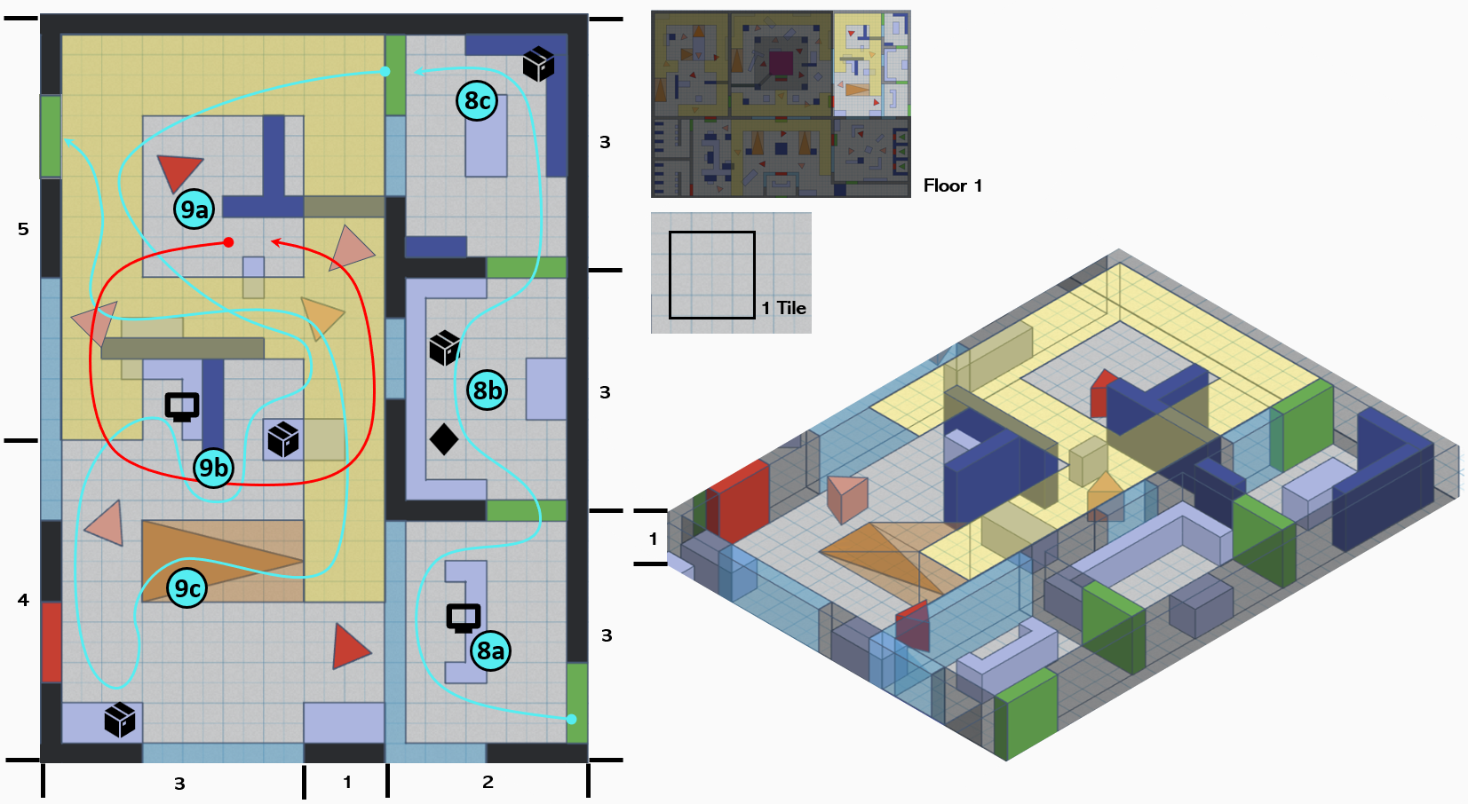
Figure 4: Assembly Room Overview Map [1]
Map Label / Stage |  | Event Summary | Event Details
8a | Narrative Beats. Check the terminal to get extra information. |  | Key Information:  - This place was originally a cannery, and people often came here to get supplies for survival.  - The diary shows UFO impact occurred a year ago.  Conveyance:  - The player can see the imprisoned residents of the Archives through the glass on the left, as well as the factory gate beyond.
8b | Exploration/Skill Challenge. Get supplies and weapon in the locker room. |  | Challenge Goal:  - Use lockpicking to get Combat Shotgun in the locker room.  Conveyance:  - You can get some bobby pins beside the locked container, which reminds you to use lockpicking skills.
8c | Exploration / Skill Challenge. Get supplies in the storage room. |  | Challenge Goal:  - Get some ammos and health kits in the storage room.
9a | Encounter |  | Enemy Information:  - Low Level Raider * 2  - Combat Shotgun * 1  - Combat Rifle * 1  - Low Level Alien * 4  - Alien Blaster * 1  - Combat Shotgun * 1  - Combat Rifle * 2
9b | Narrative Beats. Check the terminal to get extra information. |  | Key Information:  - Although aliens cannot communicate with humans in language, they can perceive human thoughts and even form an alliance with humans at one time.  - The aliens had a special constitution and could not replenish their energy with normal human food. After the energy supply on the spacecraft was exhausted, the aliens started to die within a month.
9c | Exploration. Find a way to reach the next room. |  | Challenge Goal:  - Use the platform on the second floor to reach the central control room.  Conveyance:  - Player can have a preview of the central control room and notice that the platform is connected to it.

Section 4 Central Control Room 1F
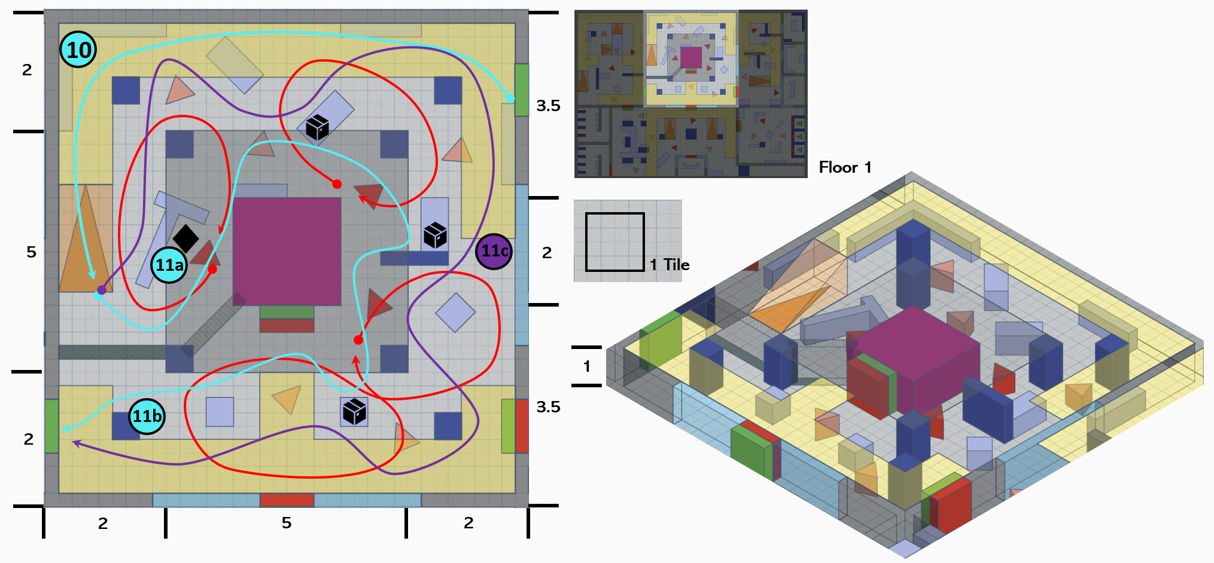
Figure 5: Central Contral Room 1F Overview Map [1]
Map Label / Stage | Event Summary | Event Details
10 | Exploration. Get to the central control room 1F using platform. | Challenge Goal:  - Use the platform and stair get to the first floor of central control room.  Conveyance:  - You can see the exit of this room at the opposite of the railing.
11a | Encounter. Get the melee weapon Machete and kills all enemies. | Enemy Information:  - Med Level Raider * 1  - Machete * 1  - Low Level Raider * 2  - Combat Shotgun * 1  - Combat Rifle * 1  - Low Level Alien * 4  - Alien Blaster * 2  - Combat Shotgun * 1  - Combat Rifle * 1  Alien Transmogrifier is recommended in this combat due to the combination of the enemies and the large flat floor.
11b | Exploration. Get the supplies and leave this room. | Challenge Goal  - Gather supplies in the room.
11c | [Optional] Skill Challenge. Use stealth to reach the goal. | Challenge Goal:  - Use stealth to kill enemies and reach your destination without being detected.  Conveyance:  - Melee weapons picked up at the edge of walls remind players that they can use stealth to kill enemies.

Section 5 Quality Inspection Room
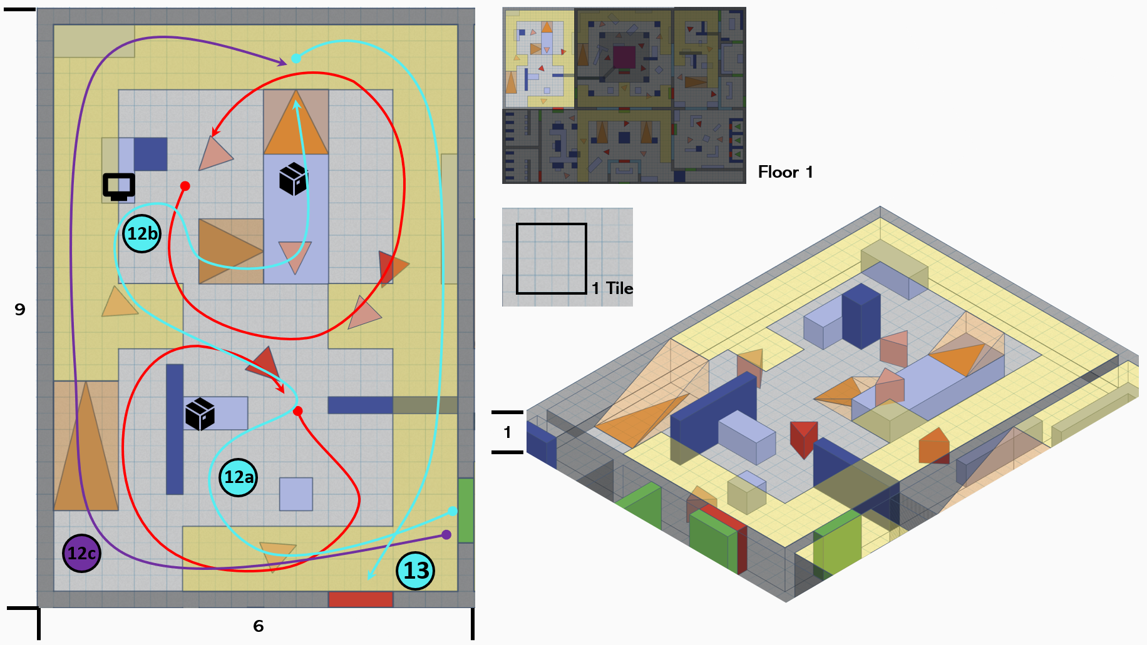
Figure 6: Quality Inspection Room Overview Map [1]
Map Label / Stage | Event Summary | Event Details
12a | Encounter | Enemy Information:  - Med Level Raider * 1  - Combat Refle * 1  - Low Level Raider * 2  - Combat Shotgun * 1  - Combat Rifle * 1  - Low Level Alien * 4  - Alien Blaster * 2  - Combat Shotgun * 1  - Combat Rifle * 1
12b | Narrative Beats. Check the terminal to get extra information. | Key Information:  - To prevent inevitable death, the aliens tried to use their remaining resources to build a transformation gun, trying to transform themselves into humans to adapt to human food and environment.  - The modified gun was stolen by humans before it was fully produced.
12c | [Optional] High platform path. | If you like fighting at a distance from your enemies, choose this path.
13 | Exploration. Get to the next room using platform. | Challenge Goal:  - Use the platform on the second floor to get to the entrance of the meeting room.

Section 6 Meeting Room
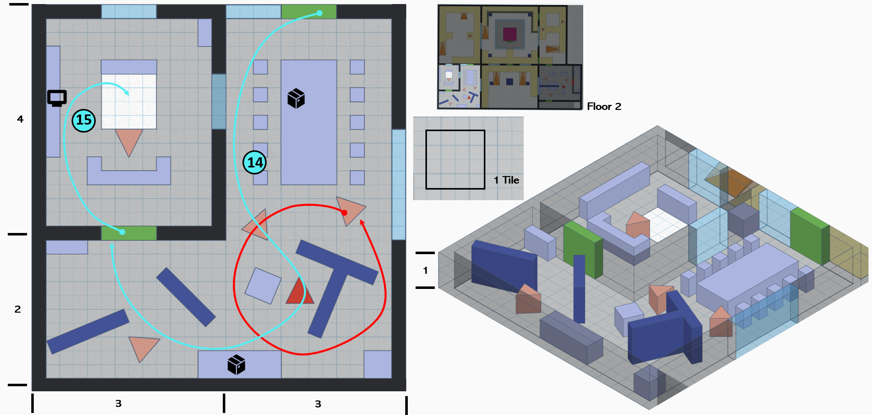
Figure 7: Meeting Room Overview Map [1]
Map Label / Stage | Event Summary | Event Details
14 | Encounter | Enemy Information:  - Med Level Raider * 1  - Combat Shotgun * 1  - Low Level Alien * 1  - Machete * 1  - Med Level Alien * 2  - Alien Blaster * 1  - Machete * 1  Conveyance:  - You can have a preview of the factory hall through the glass.
15 | Narrative Beats / Combat | Enemy Information:  - High Level Raider * 1  - Machete * 1  Key Information:  - After the aliens lost their modified guns, they launched an attack on humans.  - The remaining aliens were eventually annihilated by humans.

Section 7 Factory Hall
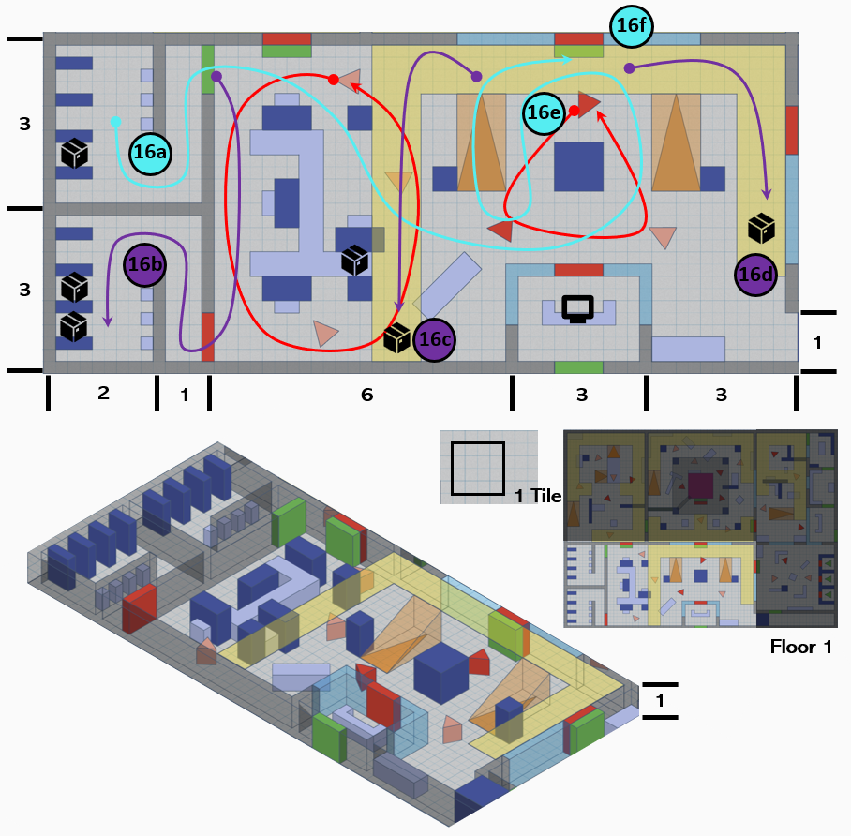
Figure 8: Factory Hall Overview Map [1]

Map Label / Stage | Event Summary | Event Details
16a | Narrative Beats / Encounter | Key Information:  - When you reach the hall, the game will switch to a cinematic view, showing Mr. X looking at you from the third floor of the control room.  Enemy Information:  - Med Level Raider * 2  - Combat Shotgun * 1  - Machete * 1  - Med Level Alien * 4  - Alien Blaster * 2  - Combat Rifle * 1  Alien Transmogrifier is recommended in this combat due to the combination of the enemies and the large flat floor.  Conveyance:  - You can have a preview of the central control room 3F through the glass.
16b | [Optional] Skill Challenge. Get extra supplies | Challenge Goal:  - Use lockpicking skills to get more supplies in the other restroom.
16c | [Optional] Exploration. Get extra supplies | Challenge Goal:  - Get extra supplies.
16d | [Optional] Exploration. Get extra supplies | Challenge Goal:  - Get extra supplies.  Conveyance:  - You can have a preview of the power supply room.
16e | Exploration. Activate the shortcut. | Challenge Goal:  - Open the chained door connected to the central control room.
16f | Exploration. Leave this room. | Challenge Goal:  - Use the platform on the second floor to get to the central control room 2F.

Section 8 Central Control Room 2F
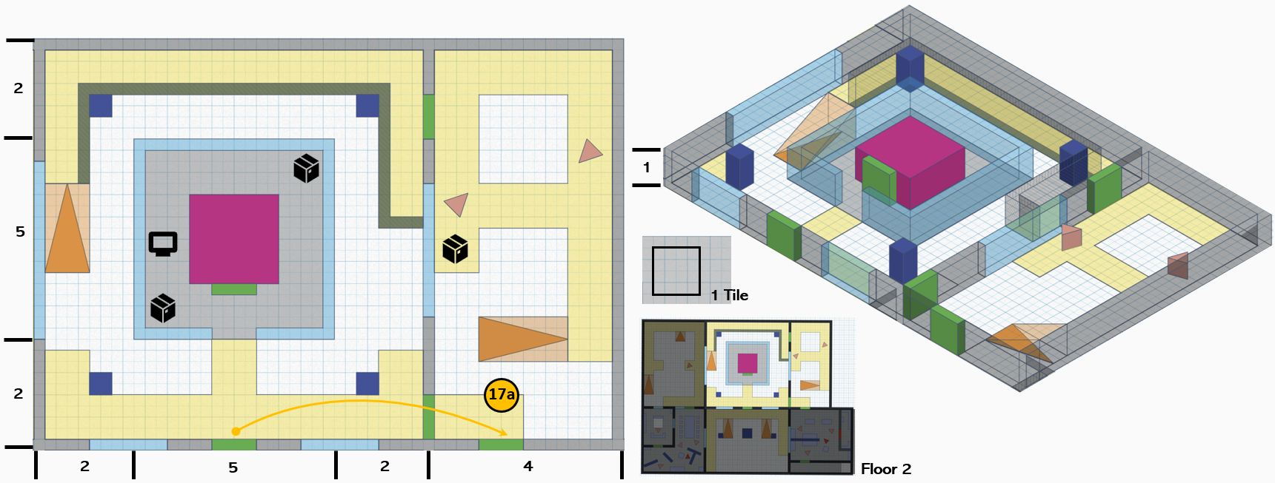
Figure 9: Central Contral Room 2F Overview Map [1]
Map Label / Stage | Event Summary | Event Details
17a | Exploration. Get to the power supply room. | Challenge Goal:  - Use the platform on the second floor to get to the power supply room.

Section 9 Power Supply Room
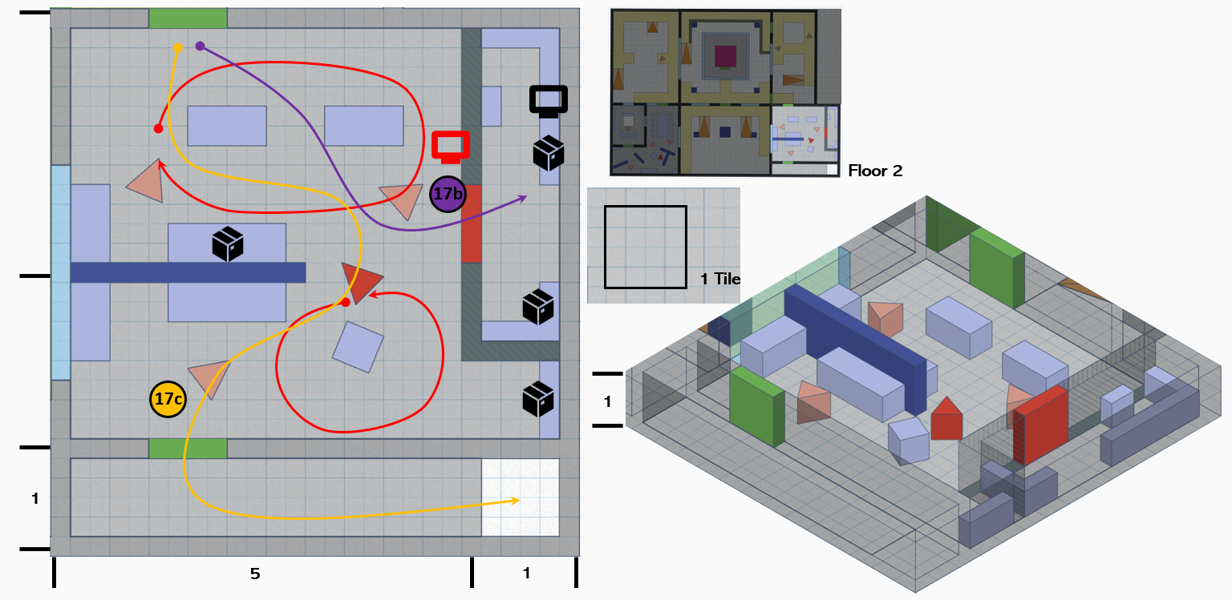
Figure 10: Power Supply Room Overview Map [1]
Map Label / Stage | Event Summary | Event Details
17b | Skill Challenge / Narrative Beats. Hack the terminal and get the extra information and supplies. | Challenge Goal:  - Use hacking skills to open the locked door and use the terminal to get extra information.  Key Information:  - The original mayor of the town was not Hansen. Hansen was just a power supply room manager.  - The original mayor of the town was obsessed with aliens and tried to please them at all costs, which even led to a shortage of resources in the town.
17c | Encounter / Exploration. Get to the first-floor corridor. | Enemy Information:  - High Level Raider * 1  - Combat Shotgun * 1  - Med Level Alien * 3  - Alien Blaster * 1  - Machete * 2  Challenge Goal:  - Go to the end of the corridor and drop from the broken floor to the first-floor corridor.

Section 10 Archives
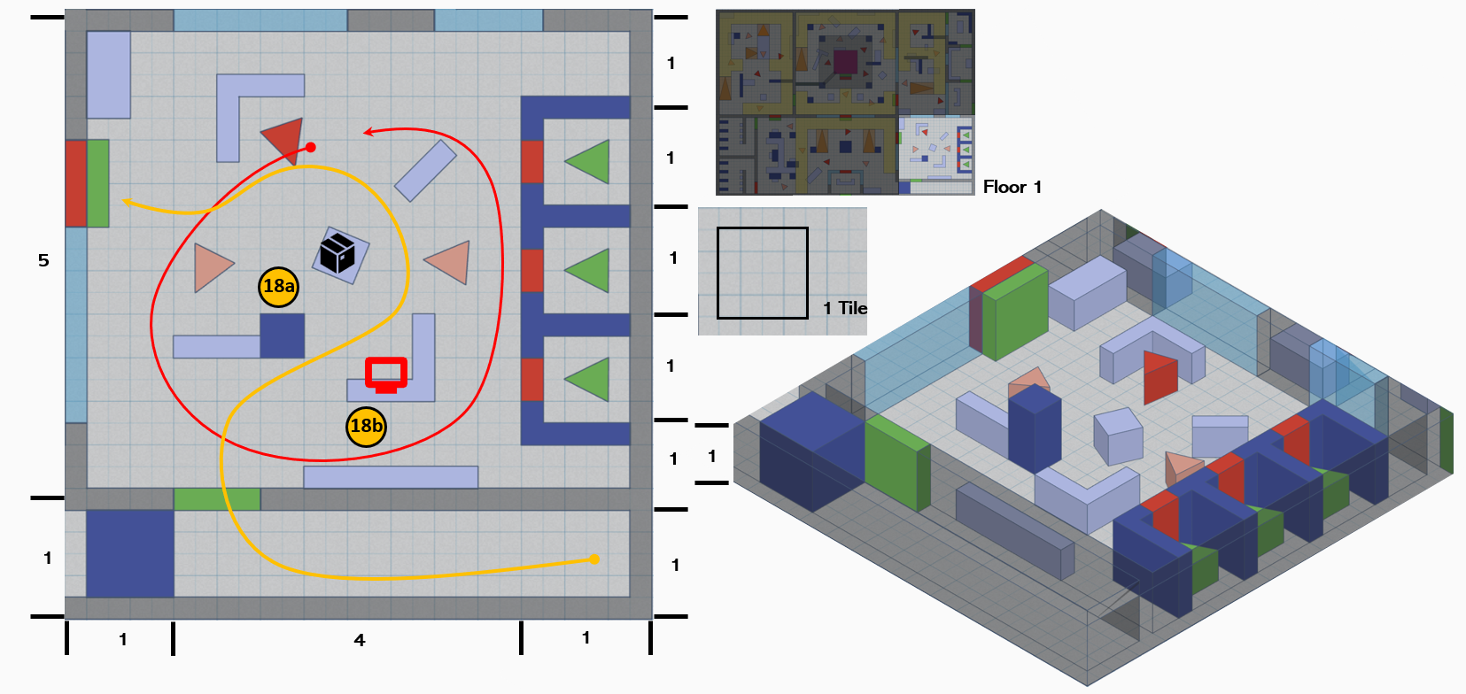
Figure 11: Archives Overview Map [1]
Map Label / Stage | Event Summary | Event Details
18a | Encounter | Enemy Information:  - High Level Raider * 1  - Combat Shotgun * 1  - High Level Alien * 2  - Alien Blaster * 1  - Machete * 1
18b | [Side quest completed] Skill Challenge / Narrative Beats. Hack the terminal to release the residents. | Challenge Goal:  - Use the hacking skills to unlock the door of the cage and release Paul’s friends out.  Key Information:  - The rescued residents expressed their gratitude to you.  - They said the aliens did not harm them but provided them with human food.  Reward:  - Stimpak * 3  - Caps * 200  - Exp + 250

Section 11 Factory Hall
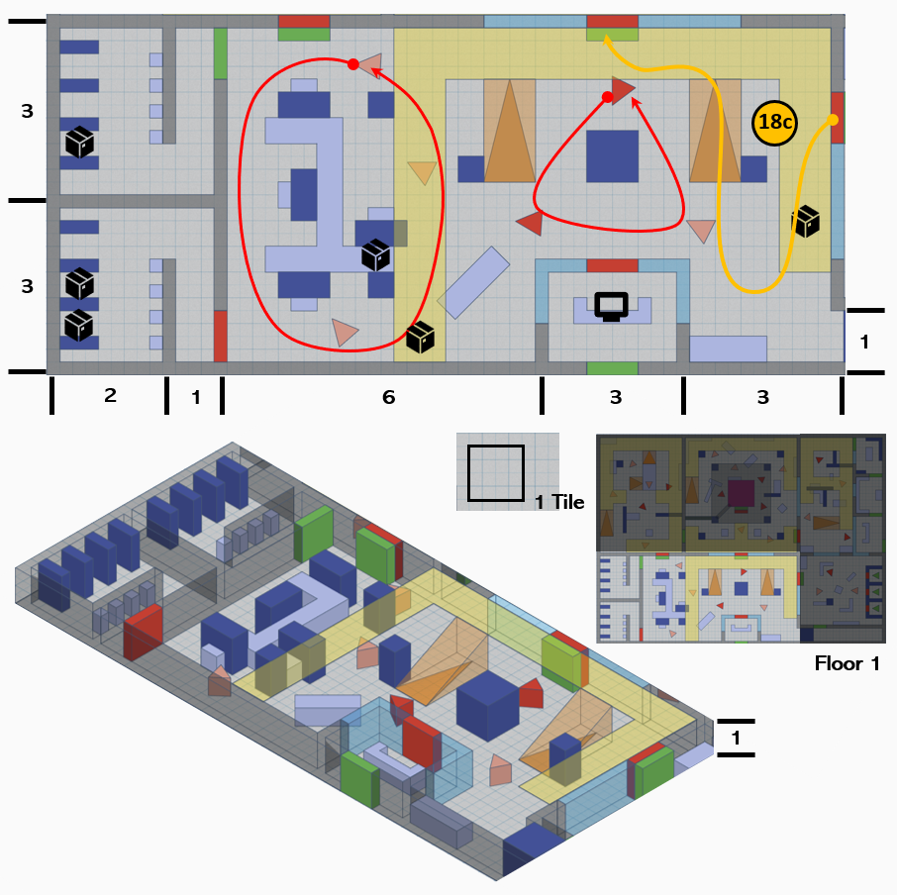
Figure 12: Factory Hall Overview Map [1]

Map Label / Stage | Event Summary | Event Details
18c | Exploration. Back to the central control room 2F. | Challenge Goal:  - Open the chained door and use the platform on the second floor to reach the central control room 2F.

Section 12 Central Control Room 2F
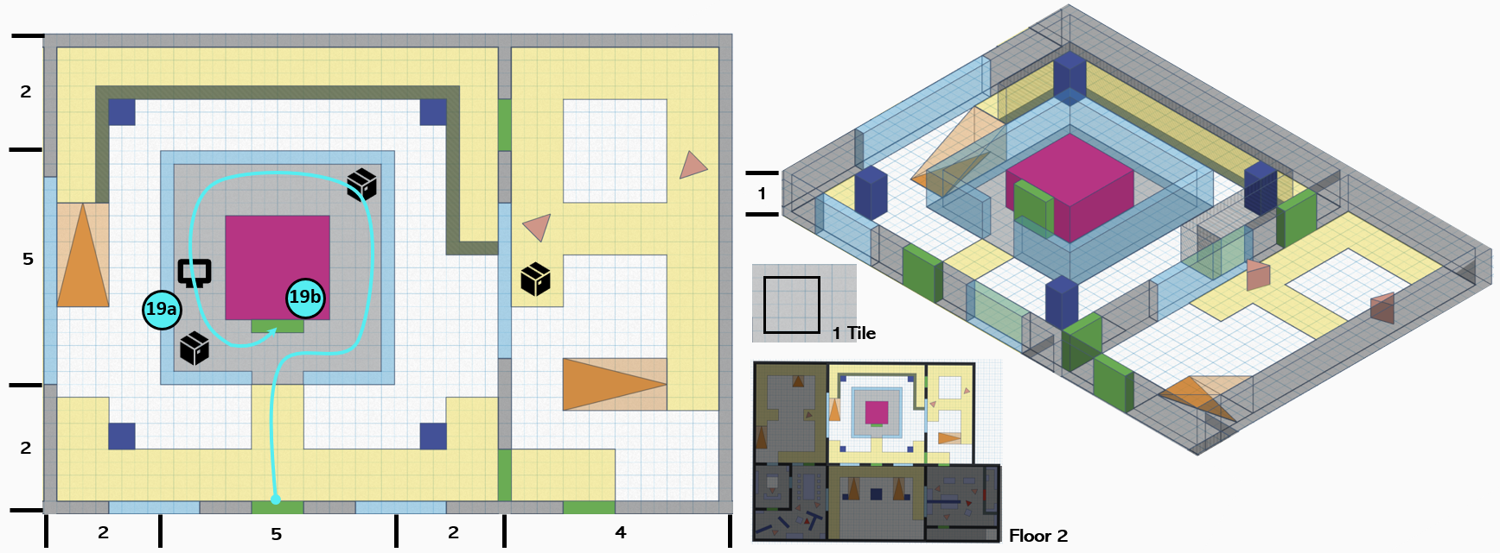
Figure 13: Central Contral Room 2F Overview Map [1]
Map Label / Stage | Event Summary | Event Details
19a | Narrative Beats. Use the terminal to get extra information. | Key Information:  - Hansen was very dissatisfied with the former mayor's actions and believed that it would only bring misfortune to the town.  - Hansen accidentally learned about the existence of alien modified guns.
19b | Exploration. Use the elevator to reach higher level. | Challenge Goal:  - Use the elevator to reach Central Control Room 3F.

Section 13 Central Control Room 3F
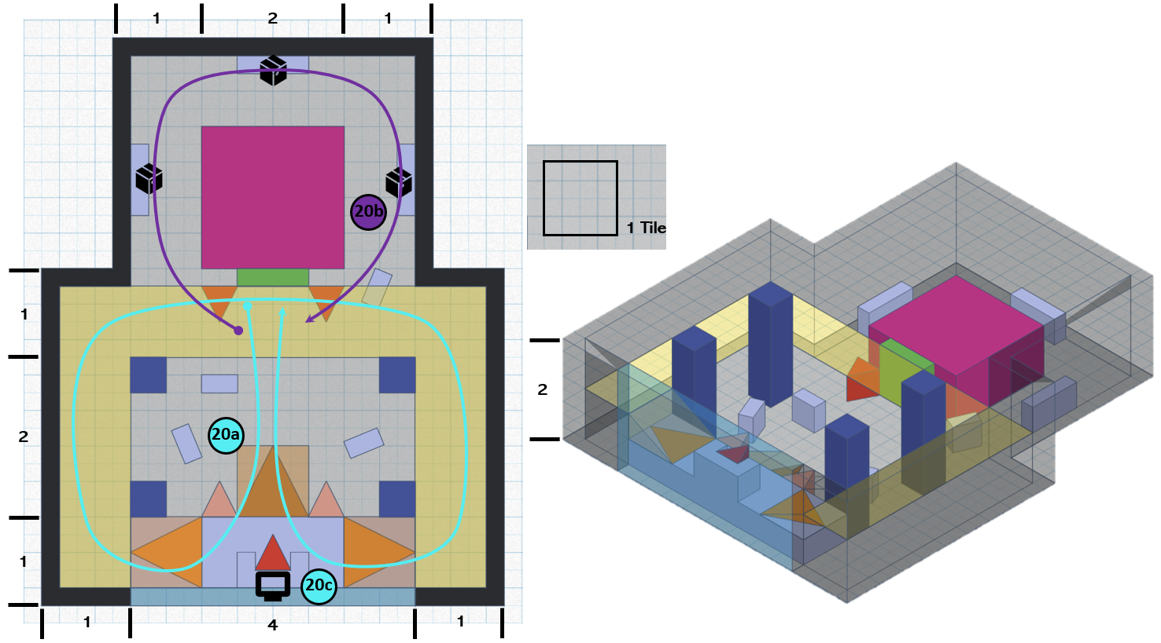
Figure 14: Central Contral Room 3F Overview Map [1]
Map Label / Stage | Event Summary | Event Details
20a | [Main Choice] Narrative Beats / Encounter (only happened when player choose to support Hansen). | Key Information:  - He took off his astronaut helmet and revealed his alien face.  - He revealed his identity as the former mayor of the town.  - He explains that Hansen stole the alien modified gun and modified it into the current Alien Transmogrifier.  - He explained that his current condition was caused by Hansen shooting him with the Alien Transmogrifier.  - He explained that many people who disobeyed him were transformed into aliens by him.  - He explains to you that he is courting the aliens in order to obtain their technology to help humans survive in the wasteland.  - He hopes you can help him use alien technology to save mankind, and he invited you to District 8 in Red Rocket for this purpose.  Main Choice:  - Choose to support Hansen, you will fight with Mr. X and his entourage. (ignore 22)  - Choose to support Mr. X, he will open the gate of the factory for you. You will fight with Hansen and his entourage in the front yard of the factory. (skip to label 21a)  Enemy Information:  - Mr. X (Boss Level Alien)  - High Level Raider * 2  - Combat Shotgun *2  - High Level Alien * 2  - Alien Blaster * 2
20b | [Optional] Exploration. Get extra supplies. | Challenge Goal:  - Go around the back of the elevator and get more supplies.
20c | Exploration. Use the terminal to open the gate of the factory. | Challenge Goal:  - Use the terminal to open the gate of the factory.

Section 14 Central Control Room 1F
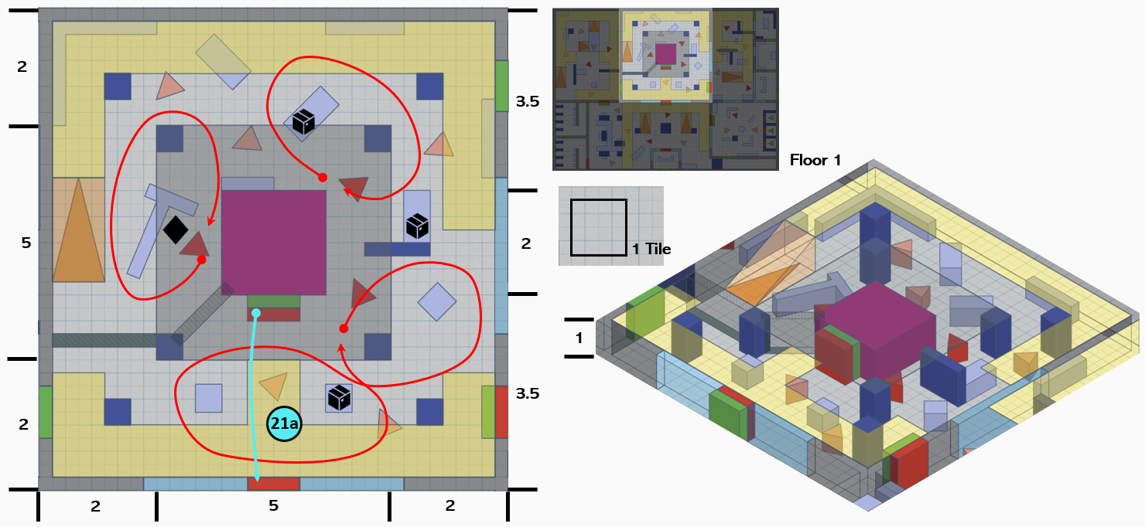
Figure 15: Central Contral Room 1F Overview Map [1]
Map Label / Stage | Event Summary | Event Details
21a | Exploration. Back to the first floor. | Challenge Goal:  - Use the elevator to go back to the central control room 1F and leave it.

Section 15 Factory Hall 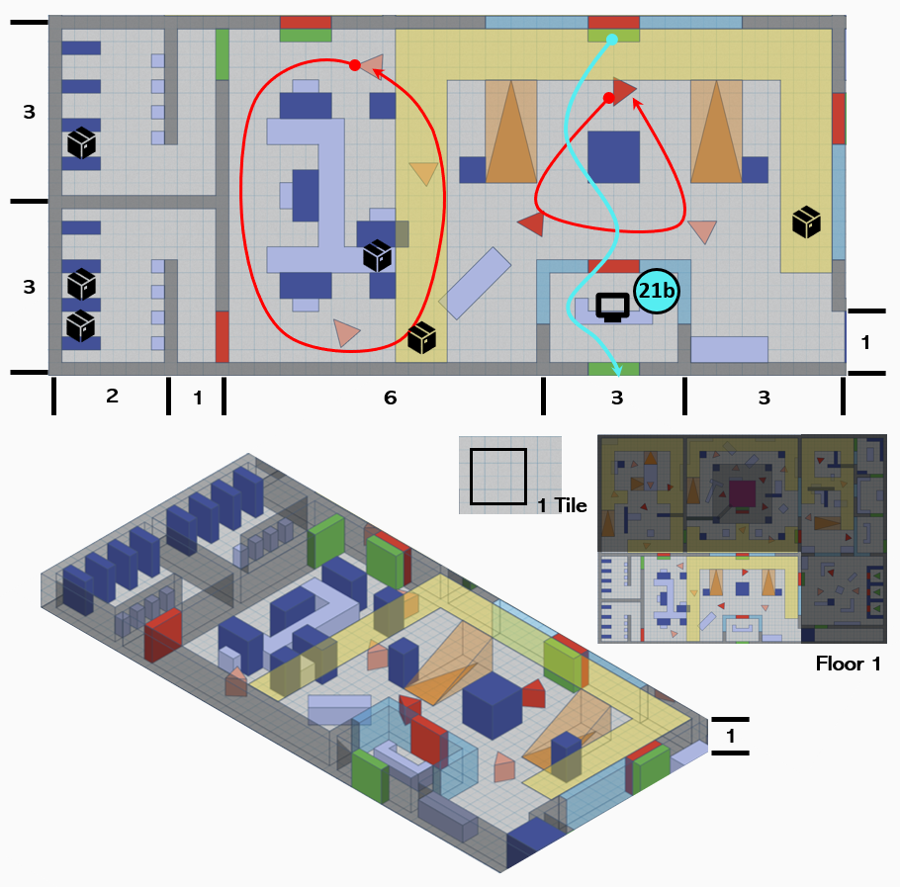
Figure 16: Factory Hall Overview Map [1]

Map Label / Stage | Event Summary | Event Details
21b | Exploration. Leave the factory. | Challenge Goal:  - Use the elevator to go back to the central control room 1F and leave it.

Section 16 District 8
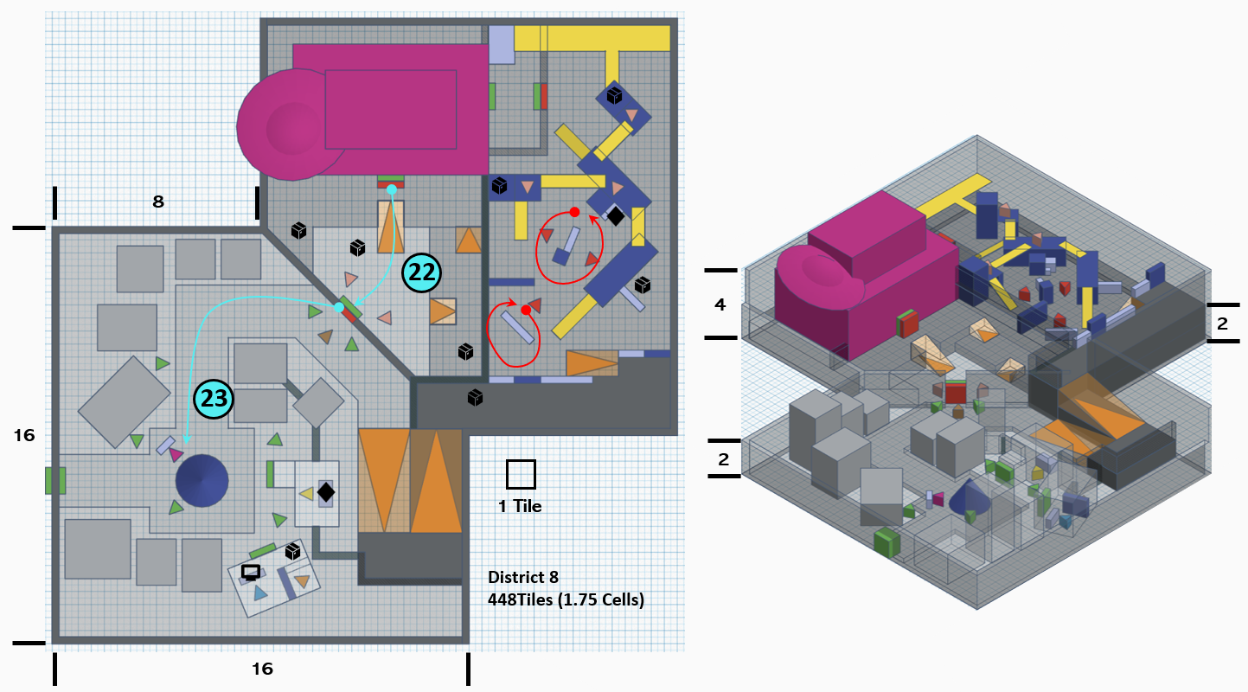
Figure 17: District 8 Overview Map [1]
Map Label / Stage | Event Summary | Event Details
22 | Narrative Beats / Encounter (only happened when player choose to support Mr. X). Confront Hansen. | Key Information:  - Hansen is disappointed and angry with your choice.  Enemy Information:  - Hansen (Boss Level Raider)  - High Level Raider * 4  - Combat Shotgun *2  - Combat Rifle *2
23 | [Main quest completed] Narrative Beats. Back to the town. | Key Information:  - If choose support Hansen  - Hansen expressed his gratitude for your contribution.  - Hansen stated that he would no longer interfere with the residents who had transformed into aliens, but he would not allow them to enter the town.  - Hansen promised that he would not do similar things again, listened to the objections, and led the residents to revitalize the town.  - Most residents of the town have a positive attitude towards the incident.  - Some residents are opposed and believe aliens should live with residents because they are compatriots.  - If choose support Mr. X  - Mr. X is happy with the choice you made.  - Mr. X promised to use alien technology to protect humans from radiation disasters.  - Many aliens appeared in the town. Some people were curious about them, while others were very resistant, even though they knew these were their compatriots.  - The old people in the town were very dissatisfied with Mr. X becoming the mayor again because they knew that he won't care about the lives of old people who are useless to the town.  Reward:  - Components * 10  - Caps * 350  - Exp + 400

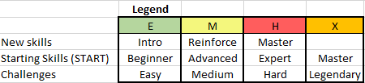
Skill Progression Chart
Figure 18: Skill Progression Chart

