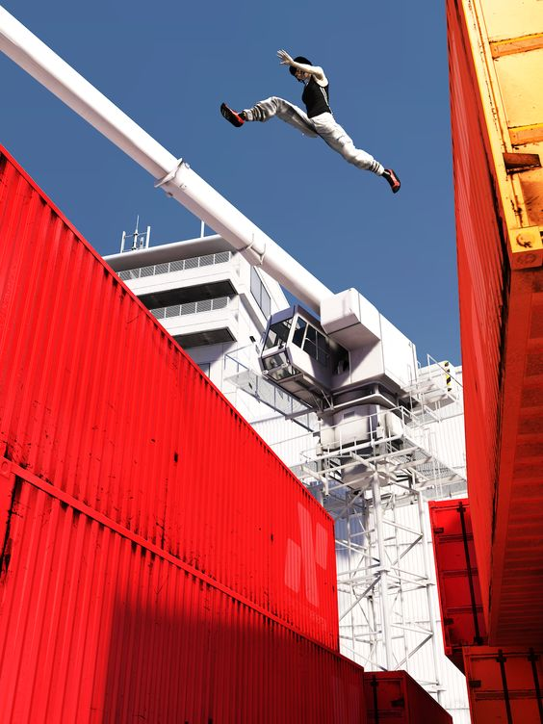
Cover Image

Dying Light: Edge Runner
  - Version 1.0
Designer: | Wilbur Wang
Document Date: | 9/28/2024
Intended Level Delivery Date: | 12/1/2025

Document Revisions Table
Version | Description | Requestor | Date
1.0 | Initial Document | Prof Stephens | 9/29/2024

Table of Contents
Table of Contents 2
Table of Figures 2
Level Summary 3
Quick Summary 3
Level Feature Overview 3
Development Schedule 4
Level Details 5
Level Map(s) 5
Map(s) 5
Gameplay Summary 6
Skill Progression Chart 8
References 9
Appendix A: Aesthetic References 10
Exterior Visual Theme 10
Interior Visual Theme 11

Table of Figures
Figure 1: Overview Map [1] 5
Figure 2: Skill Progression Chart 8
Figure 3: Exterior Visual Theme [2], [3], [4], [5] 10
Figure 4: Interior Visual Theme [6], [7], [8], [9] 11

Level Design Document

Level Summary

Quick Summary
This is a Dying Light single-player custom level with a process of about 10 minutes. This mission takes place after the game's main mission "First Assignment". The player needs to go to Downtown to rescue the trapped companion and take him away. This level has a rich vertical design, designed to test the player's application of advanced climbing skills.

Level Feature Overview
Category | Sub-Category | Feature List
Player | Player Weapons | - Khukuri Machete
 | Player Skills/Abilities | - Parkour: Run, Jump, Climb, Sprint, Zipline  - Combat: Melee, Kick, Head Stomp, Assassinate
AI | Enemies | - Biter  - Gas Tank  - Toad  - Screamer
 | Friendlies | - Rahim (Quest Giver)
Challenges | Gameplay Themes | - Chasing  - Vertical Parkour  - Melee
 | Obstacles/Hazards | - Explosive Barrel
 | New/Unique Gameplay | - N/A
Context | Where Fits in Game | - This is an early tutorial quest given by Rahim to teach the player's advanced climbing skills.  - After the quest “FIRST ASSIGNMENT”
 | Challenge Fit | - All mechanics come from the main game itself.
 | Additional Info | - N/A
Aesthetics | Major Visual Themes | - Downtown  - Central Loop  - Office
 | Setting/Mood | - Dusk

Development Schedule
Milestone | Date
LDD | 9/29/2024
Whitebox | 10/13/2024
Initial Gameplay | 10/20/2024
Gameplay Complete | 11/3/2024
Aesthetics | 11/24/2025
Launch | 12/1/2025

Level Details

Level Map(s)

Map(s)
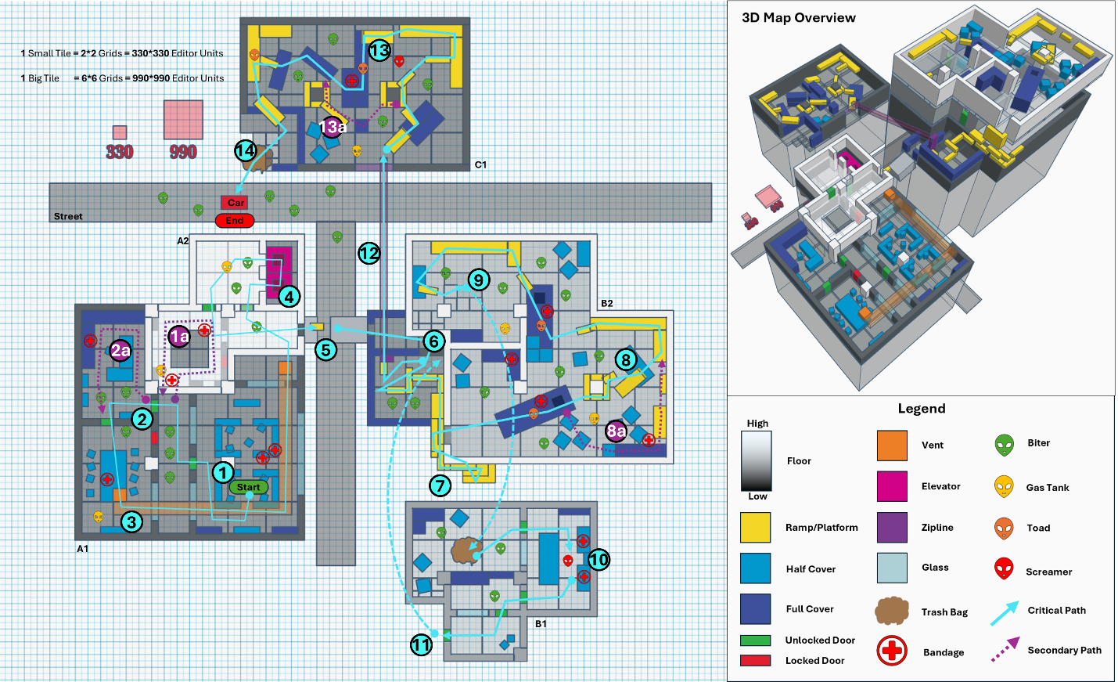
Figure 1: Overview Map [1]

Gameplay Summary
Map Label | Gameplay Summary |  | Other Notes
1 | The player starts the mission in the office, picks up the nearby weapons and bandages, and leaves the office into the corridor. | Players can see the broken sky corridor through the glass.  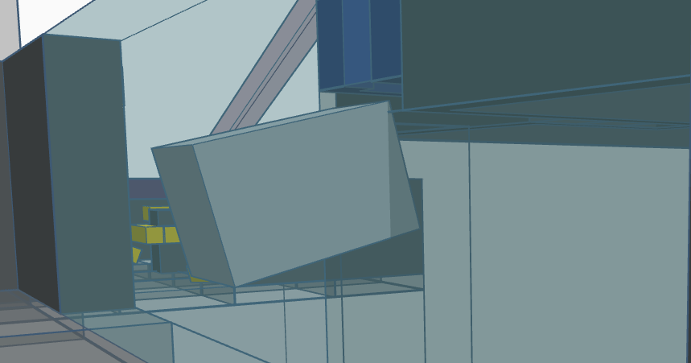
1a | Explore the office lobby for additional resources. | - Encounter: Biter
2 | Enter the executive room, then the meeting room. | - Encounter: Biter
2a | Explore the Executive Room to obtain quest items and complete side quest. | - Encounter: Biter
3 | Climb up the vent and follow it to the elevator shaft. | - Encounter: Biter, Gas Tank  - Skill Challenge: Head Stomp, Vent
4 | Climb up to the second floor of the office through the elevator shaft. | - Encounter: Biter, Gas Tank  - Skill Challenge: Head Stomp
5 | Go through the hole in the wall to reach the top of the sky corridor and jump to another building. | - Skill Challenge: Sprint Jump
6 | Use double jumps to climb through the gaps between buildings to reach the roof garden. | - Encounter: Biter, Gas Tank  - Skill Challenge: Double Jump Climb
7 | Climb up the scaffolding around the building to the upper floors. | - Skill Challenge: Double Jump Climb
8 | Move on containers or scaffolding to avoid zombies on the ground. | - Encounter: Biter, Gas Tank, Toad  - Skill Challenge: Head Stomp
8a | Explore another path to get extra supplies. | - Encounter: Biter, Gas Tank, Toad  - Skill Challenge: Climb, Head Stomp
9 | Fall to the lower floor through the broken hole in the floor. | - Encounter: Biter, Gas Tank  - Skill Challenge: Head Stomp
10 | Enter the control room, kill Screamer and get the mission item: Zipline. | - Encounter: Biter, Screamer  - Skill Challenge: Head Stomp, Assassinate
11 | Leave the room, backtrack to the roof garden, and activate the zipline. | N/A
12 | Use the zipline to move to the building on the opposite side of the road. | - Skill Challenge: Zipline
13 | Move on containers or scaffolding to avoid zombies on the ground and find the right time to kill the Screamer. | - Encounter: Biter, Gas Tank, Toad, Screamer  - Skill Challenge: Head Stomp, Assassinate
13a | Use the Double Jump Climb skill to find a potential shortcut to avoid Screamer. | - Encounter: Biter, Gas Tank, Toad  - Skill Challenge: Head Stomp, Double Jump Climb
14 | Climb over the guardrail from the scaffolding and land on the ground, enter the vehicle, and complete the mission. | N/A

Skill Progression Chart
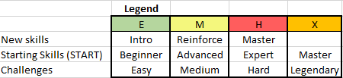

Figure 2: Skill Progression Chart

References
[Cover Image] “The Art Of Gaming”, Pinterest. [Online] Available: https://www.pinterest.com/pin/232146555771290314/. [Accessed: 9/28/2024].
[1] Wang, Wilbur. Created in Tinkercad, edited in PowerPoint. [Accessed:9/28/2024].
[2] Captured from Pinterest. [Online] Available: https://www.pinterest.com/. [Accessed: 9/28/2024].
[3] “Lanwei, architecture interrupted”, domus. [Online] Available: https://www.domusweb.it/en/photo-essays/2012/11/27/lanwei-architecture-interrupted.amp.html. [Accessed; 9/8/2024].
[4] “Central Loop”, Dying Light 2 Wiki. [Online] Available: https://dyinglight.fandom.com/wiki/Dying_Light_2_Stay_Human. [Accessed: 9/28/2024].
[5] Captured from Pinterest. [Online] Available: https://www.pinterest.com/. [Accessed: 9/28/2024].
[6] Captured from Pinterest. [Online] Available: https://www.pinterest.com/. [Accessed: 9/28/2024].
[7] Captured from Pinterest. [Online] Available: https://www.pinterest.com/. [Accessed: 9/28/2024].
[8] Rodolfo Galvez, “Unfinished Building”, ArtStation, 2020. [Online] Available: https://www.artstation.com/artwork/ea52z3. [Accessed: 9/28/2024].
[9] Captured from Pinterest. [Online] Available: https://www.pinterest.com/. [Accessed: 9/28/2024].

Appendix A: Aesthetic References

Exterior Visual Theme
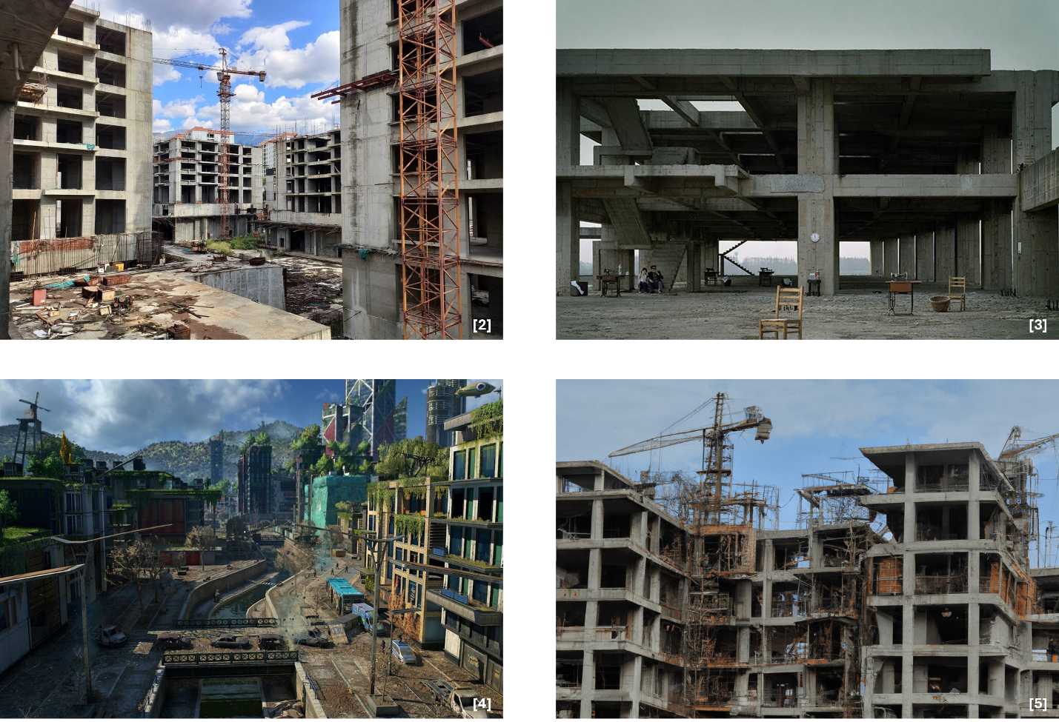
Figure 3: Exterior Visual Theme [2], [3], [4], [5]

Interior Visual Theme
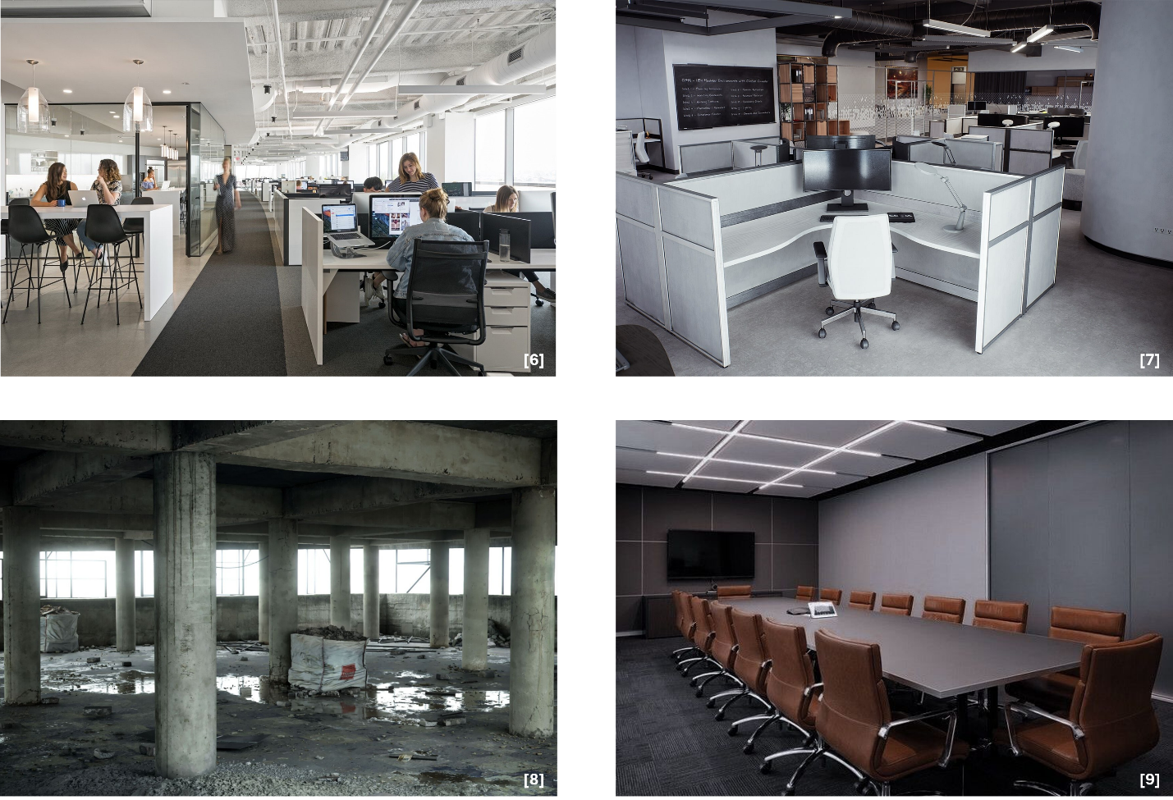
Figure 4: Interior Visual Theme [6], [7], [8], [9]

