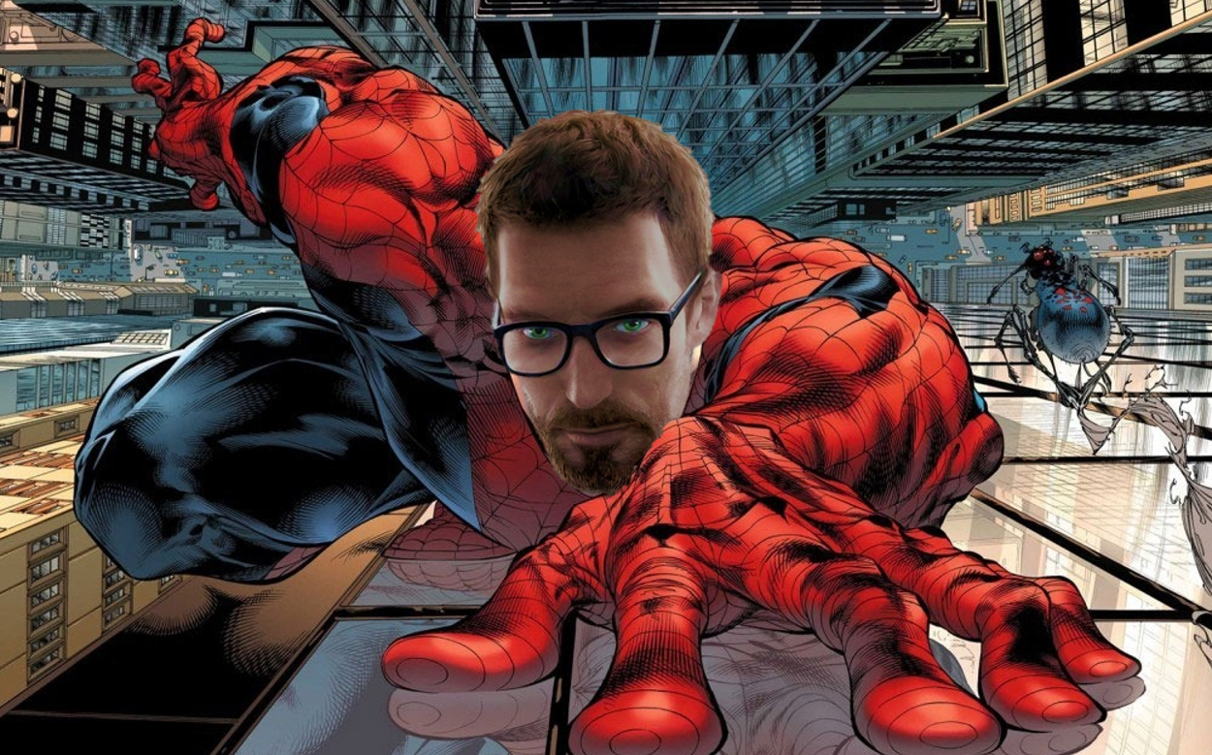
Cover Image

Half-Life 2: Become Spider
  - Version 1.0
Designer: | Wilbur Wang
Document Date: | 5/27/2024
Intended Level Delivery Date: | 7/14/2024

Document Revisions Table
Version | Description | Requestor | Date
1.0 | Initial Document | Professor Stephens | 5/27/2024

Table of Contents
Table of Contents 2
Table of Figures 5
Level Summary 6
Quick Summary 6
Gameplay Overview 6
Level Feature Overview 6
Level Overview 7
Map Scope 7
Overview Map Layout 8
Level Details 9
Detail Maps 9
Section 1: Start Room 9
Section 2: Square 11
Section 3: Left Side Room 12
Section 4: Central Room 13
Section 5: Lobby 14
Section 6: Central Room 15
Section 7: End Room 16
Aesthetic References 18
Visual Theme: Backroom 18
Production Schedule 19
Development Schedule 19
Whitebox 19
Initial Gameplay 20
Gameplay Complete 22
Aesthetics 23
References 24

Table of Figures

Figure 1: Core Mechanic [1] 4
Figure 2: Map Scope [1] 5
Figure 3: Level Layout Overview [1] 6
Figure 4: Section 1 Breakdown [1] 7
Figure 5: Section 2 Breakdown [1] 9
Figure 6: Section 3 Breakdown [1] 10
Figure 7: Section 4 Breakdown [1] 11
Figure 8: Section 5 Breakdown [1] 12
Figure 9: Section 6 Breakdown [1] 13
Figure 10: Section 7 Breakdown [1] 14
Figure 11: Backroom Reference [2], [3], [4], [5], [6], [7] 16

Level Summary

Quick Summary
This is a gravity-themed Half-Life 2 single-player level made in Hammer editor in which the player needs to use the ability to walk on walls to solve puzzles and reach the end.

Gameplay Overview
The core gameplay of this level is to move on different planes to solve the puzzle and find a way out. Players can find connectors at the seams where the walls meet the ground, or where the walls meet the ceiling. Those connectors can help players move from one plane to a different plane.
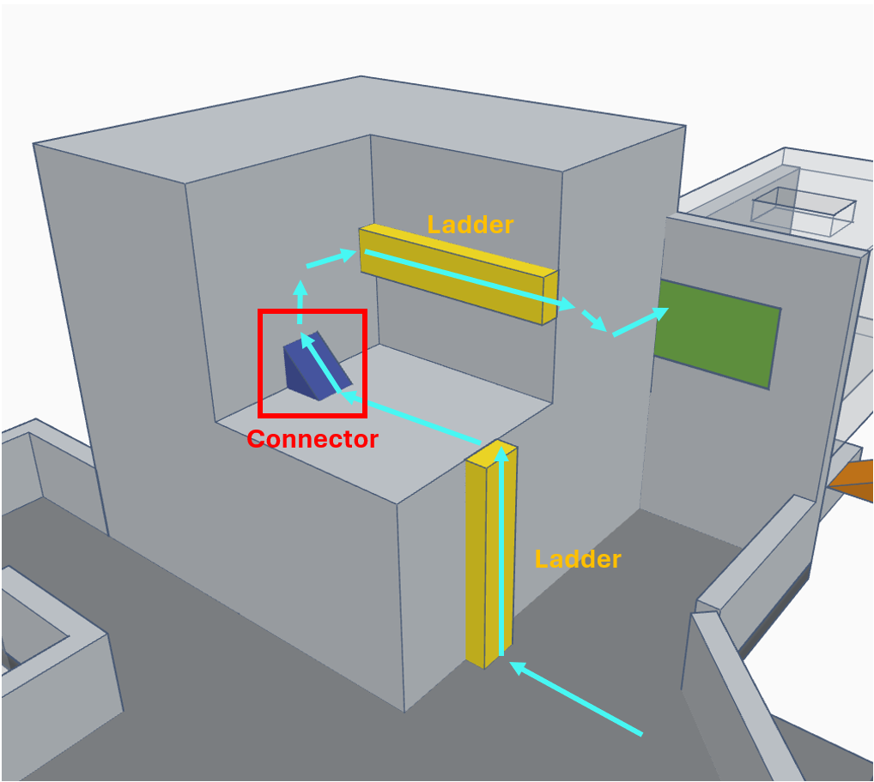
Figure 1: Core Mechanic [1]

Level Feature Overview
Category | Sub-Category | Feature List
Player | Player Weapons | - Crowbar
 | Player Skills/Abilities | - Walk on the Wall
AI | Enemies | - Antlion  - Antlion Guard
 | Friendlies | - N/A
Challenges | Gameplay Themes | - Gravity
 | Obstacles/Hazards | - Bottomless Hole
 | New/Unique Gameplay | - Walking on the Wall
Aesthetics | Major Visual Themes | - Backroom
 | Setting/Mood | - Cloudy

Level Overview

Map Scope
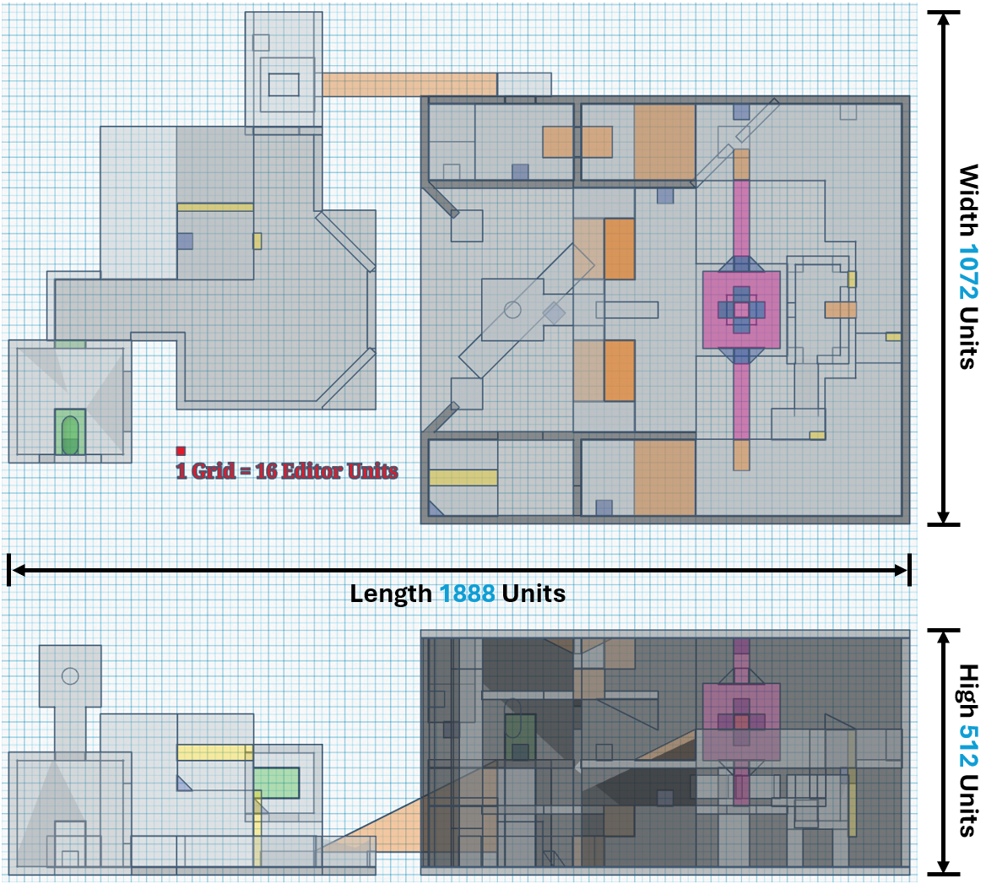
Figure 2: Map Scope [1]

Overview Map Layout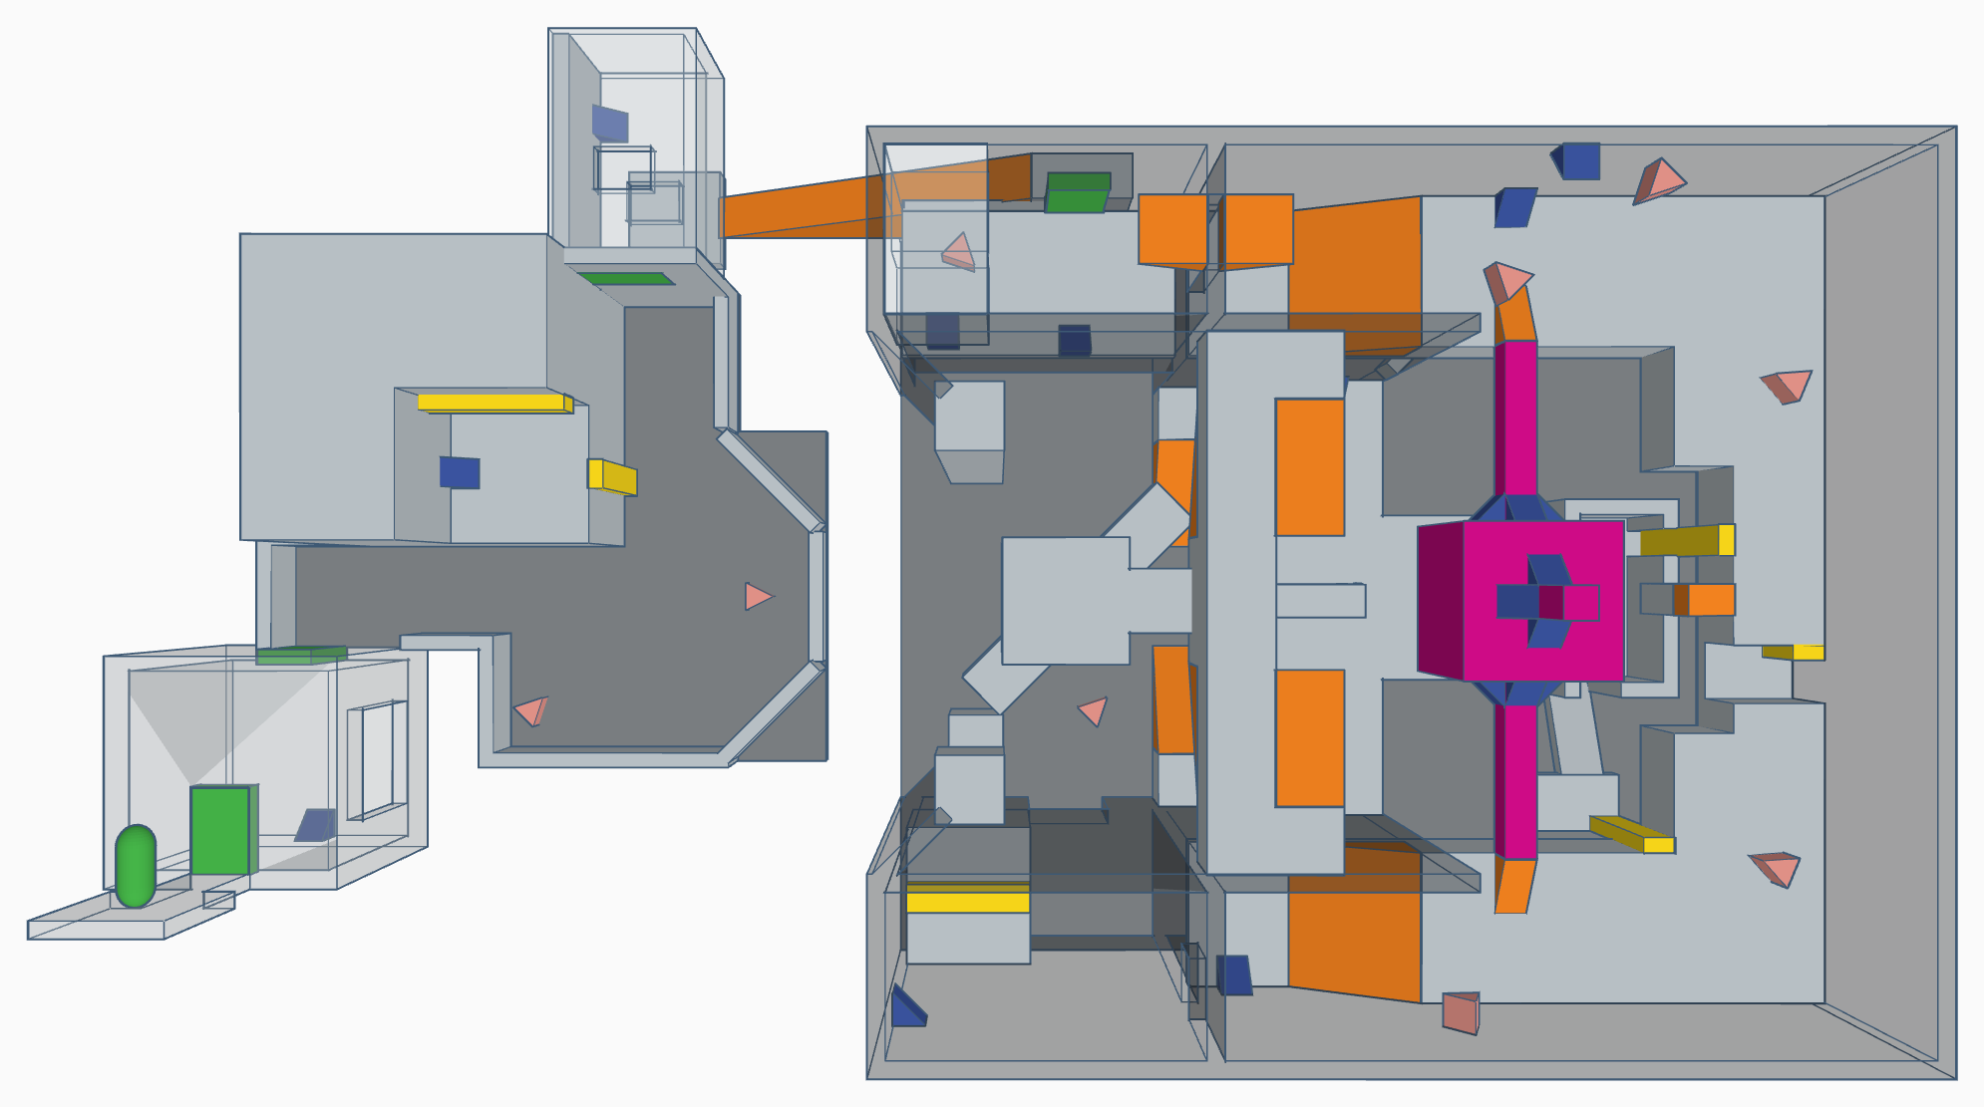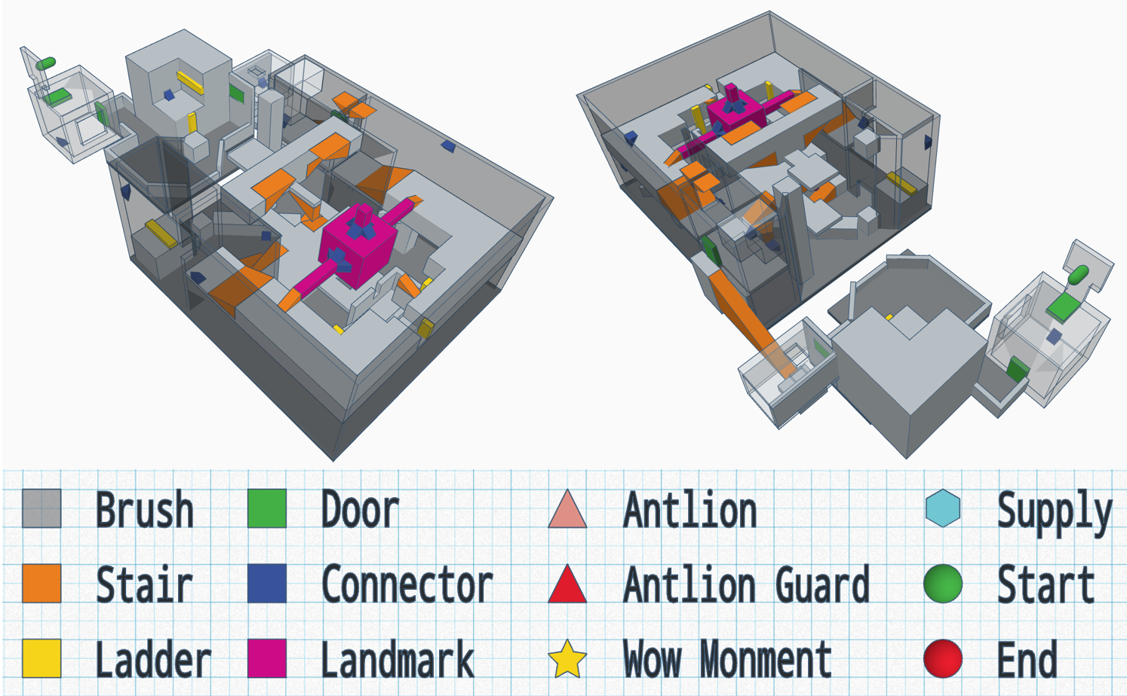
Figure 3: Level Layout Overview [1]

Level Details

Detail Maps

Section 1: Start Room
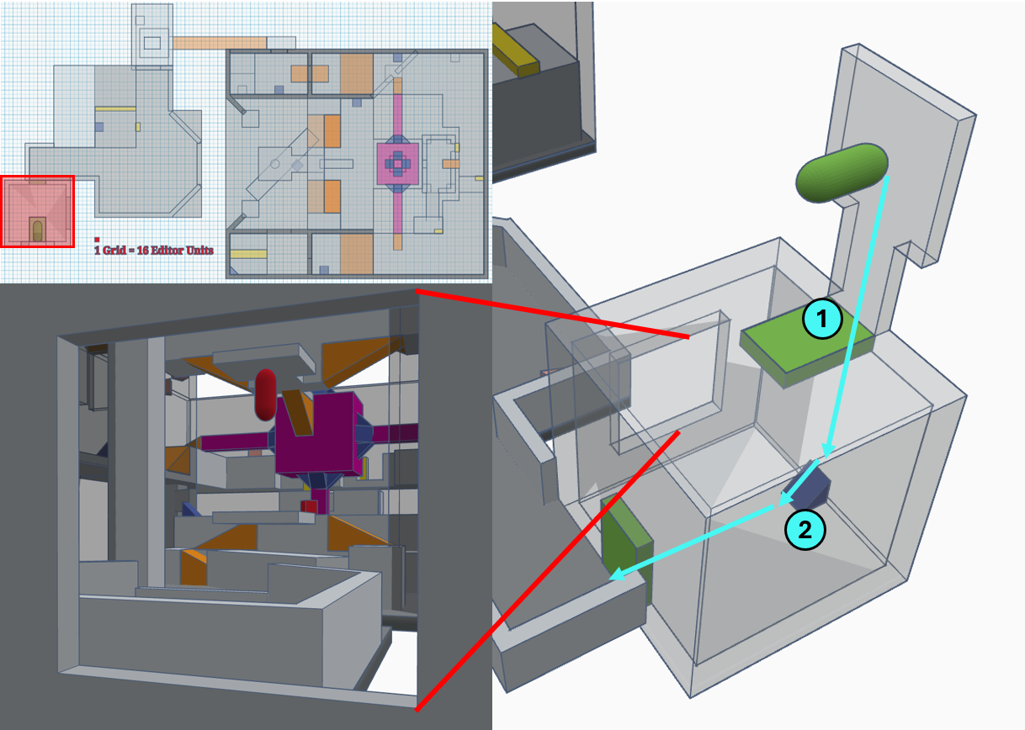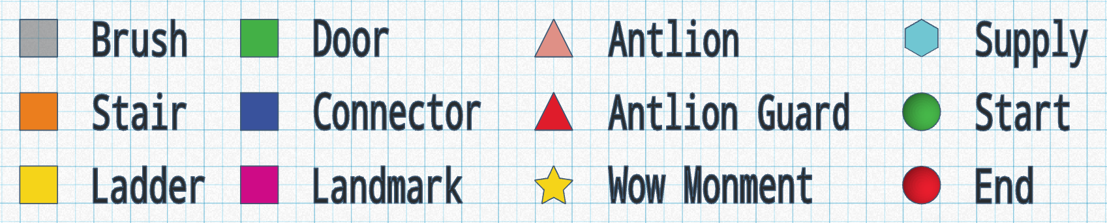
Figure 4: Section 1 Breakdown [1]
Map Label / Stage | Event Summary | Event Details
1 | Enter the Start Room. | - The art style of the is Backroom, so the gate to the start room is set as the lab of the Backroom, which also rationalizes the ultra-realistic level structure.
2 | Use the connector to rotate the map and walk onto the wall. | - The first time the player uses the connector, which is a wow moment.  - Player can have a preview of the main part of the level from the window.

Section 2: Square
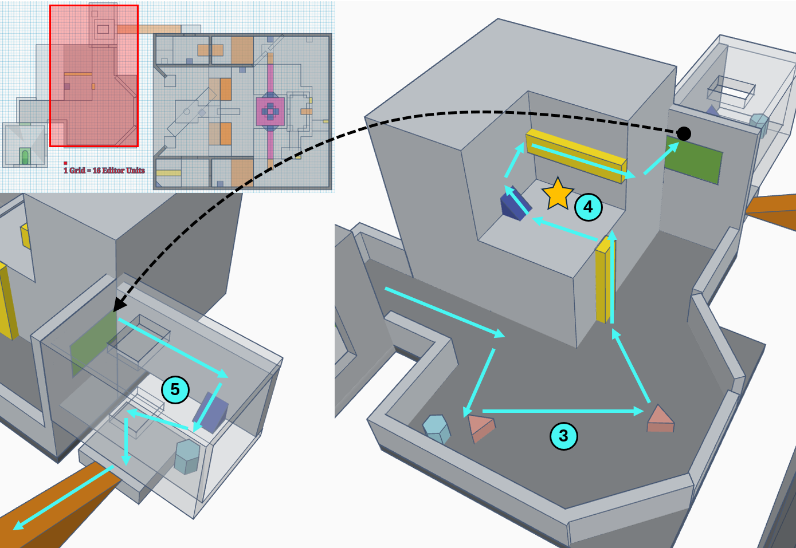
Figure 5: Section 2 Breakdown [1]

Map Label / Stage | Event Summary | Event Details
3 | Leave the Start Room and defeat the enemies in the square. | - Encounter  - Two Antlions, one will sneak up on you from behind.
4 | Use the ladder and connector to get the door | - The second time the player uses the connector, and lets the player know that they can use ladders even though walking on the wall.
5 | Use the connector to go back to the floor and fall from the broken hole. | - Players can get some supplies from the coming combat.

Section 3: Left Side Room
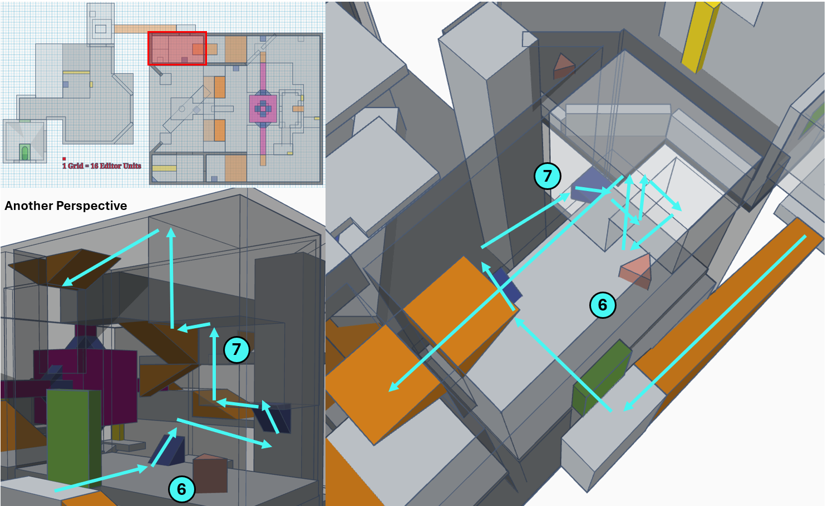
Figure 6: Section 3 Breakdown [1]

Map Label / Stage | Event Summary | Event Details
6 | Enter the Left Side Room and defeat the enemy. | - Encounter  - One Antlion.
7 | Use the connector to get to the ceiling. Go through the window to the next room. | - When the player reaches a platform that is on the same plane as the ceiling, the player needs to "fall" upwards to reach the ceiling.

Section 4: Central Room
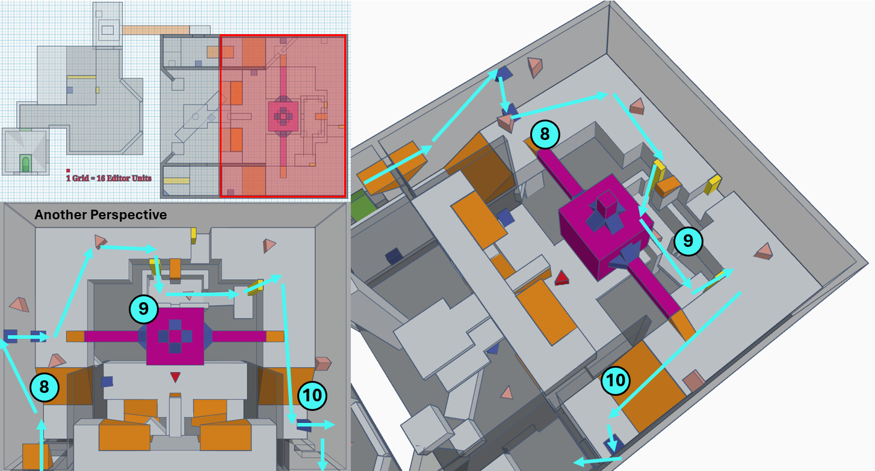
Figure 7: Section 4 Breakdown [1]

Map Label / Stage | Event Summary | Event Details
8 | Enter the Central Room and use connector to go back to the floor and defeat the enemies. | - Encounter  - Three Antlions, one is on the ceiling, two are on the floor.
9 | Use the ladder to reach the supply room and get some supplies. | - Encounter  - One Antlion.
10 | Leave the supply room and use connector to walk onto the wall. | - Encounter  - Two Antlions. One is on the wall, and one will sneak up on you from behind.

Section 5: Lobby
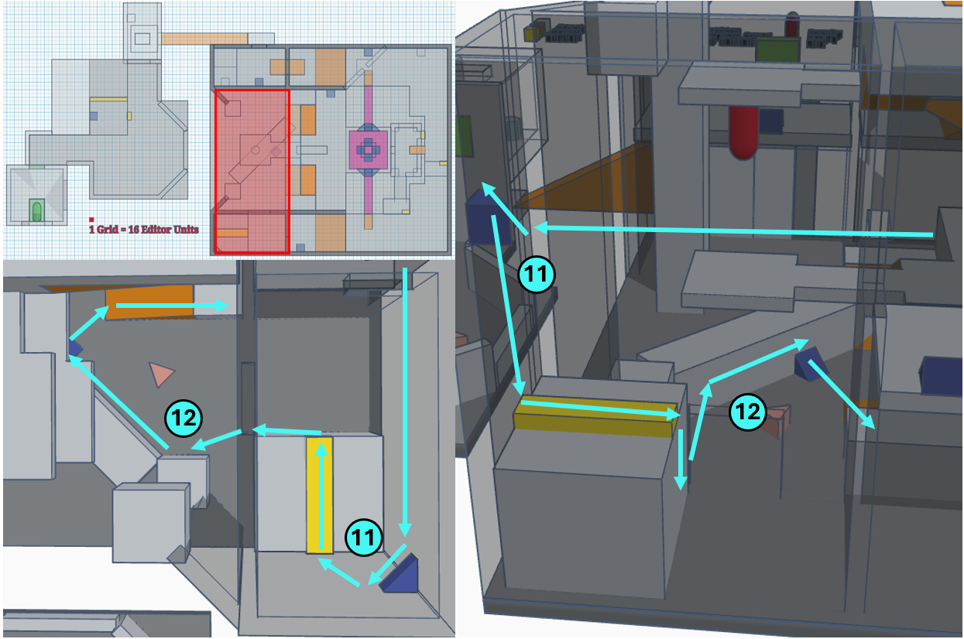
Figure 8: Section 5 Breakdown [1]

Map Label / Stage | Event Summary | Event Details
11 | Enter the Right Side Room and use connector and ladder to get to the plane parallel to the wall. | N/A
12 | Jump to the fallen pillar and use connector to get to the floor. | - Encounter  - One Antlion.

Section 6: Central Room
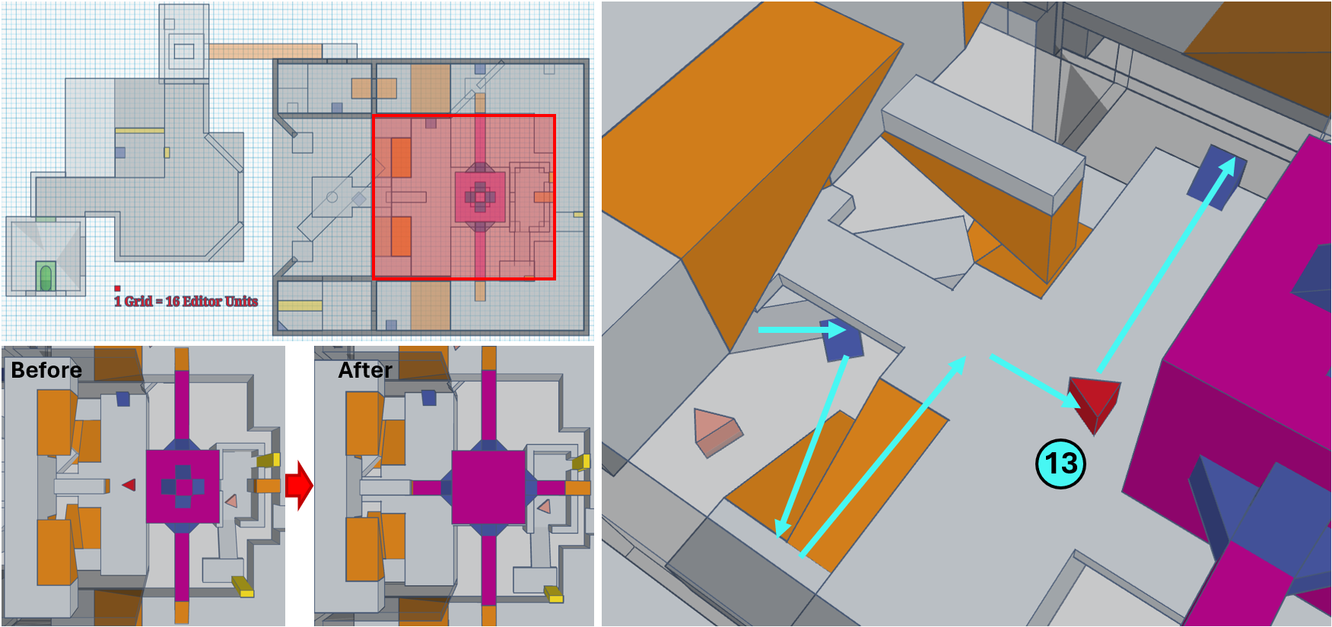
Figure 9: Section 6 Breakdown [1]

Map Label / Stage | Event Summary | Event Details
13 | Walk onto the central platform and defeat the BOSS, then make the landmark rotate the landmark 90 degrees. | - Rotate the landmark 90 degrees so that the two long columns are connected to the platform on the ceiling.

Section 7: End Room
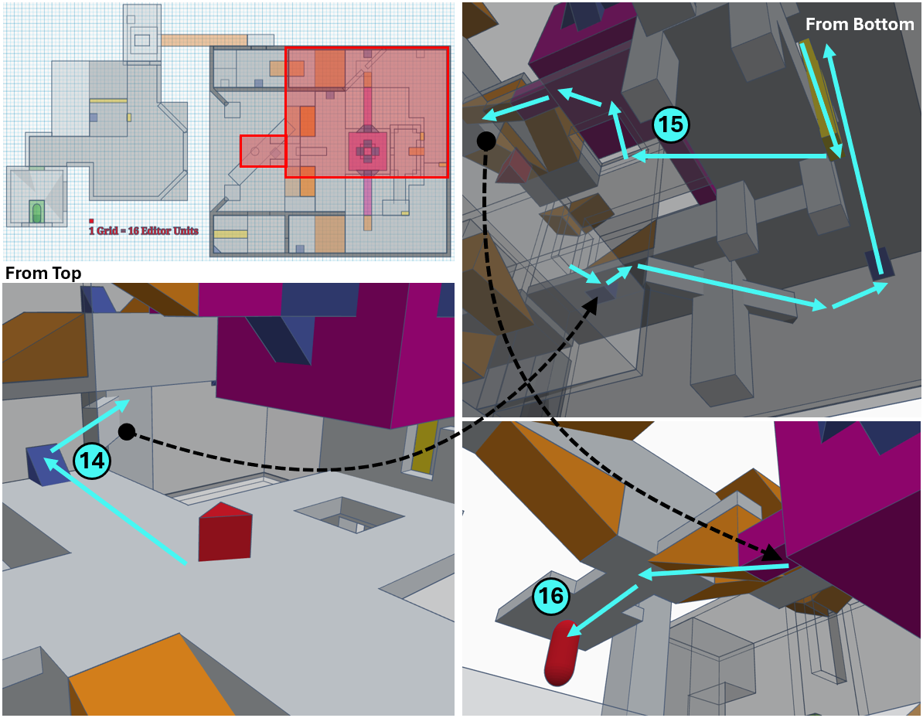
Figure 10: Section 7 Breakdown [1]

Map Label / Stage | Event Summary | Event Details
14 | Keep going and use connector and pillar to get to the bottom of the platform. | N/A
15 | Use the ladder to get to the bottom of the supply room and “fall” to the bottom of the landmark through the hole to get to the upside-down platform on the ceiling. | N/A
16 | Press the button and close the backroom to finish the level. | N/A

Aesthetic References
The layout structure of the level is surreal, so I chose the backroom style as the aesthetic theme to create a weird atmosphere and explain the rationality of the surreal level structure.

Visual Theme: Backroom
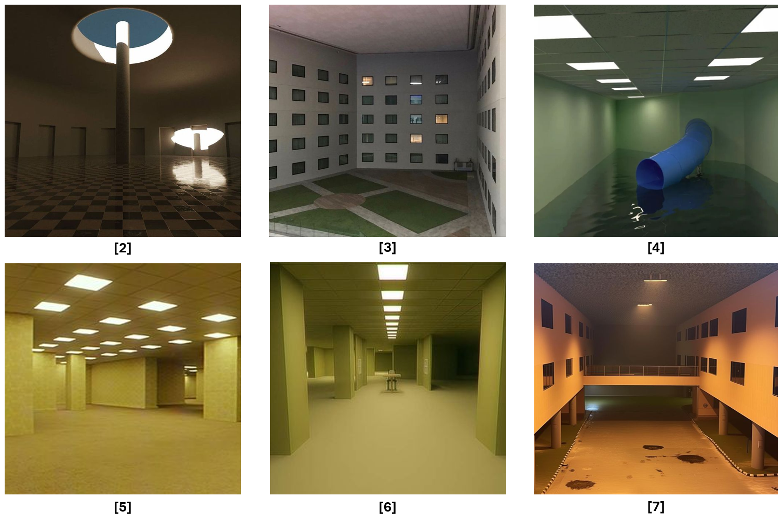
Figure 11: Backroom Reference [2], [3], [4], [5], [6], [7]

Production Schedule

Development Schedule
Milestone | Date
LDD | 5/27/2024
Whitebox | 6/3/2024
Initial Gameplay | 6/17/2024
Gameplay Complete | 7/1/2024
Aesthetics | 7/8/2024
Launch | 7/14/2024

Whitebox
A-ID | Priority | Task | Conditions of Satisfaction | Time Estimate (hrs)
WB-1 | High | BSP geometry to 60%. | - Exterior Space  - Walls  - Ceilings  - Floors  - Platforms  - Stairs  - Ladders  - Pillars  - Windows  - Doorways  - M/L Objects  - Start Point  - No Leaks | 2
WB-2 | High | Gameplay to 60% | - Encounter  - Enemy Type  - Enemy Position  - Info Node  - Mechanic  - Map Rotating | 2
WB-3 | High | Basic Lighting | - Ensure that there are no obvious dark corners in the indoor area that may affect the game process. | 0.5
WB-4 | High | Test and adjust the layout | - Whether the level is in well scope?  - Whether the layout is in good scale (no stuck)?  - Whether the sightline is good? | 1.5
WB-5 | High | Test and adjust the gameplay | - Whether the level can be completed?  - Whether the encounter is in good pacing? | 1.5
WB-6 | Medium | BSP geometry to 80%. | - Exterior Space  - Basic Terrain Texture  - Interior Space  - Full Cover  - Half Cover  - Windows Position Polish  - Stairs Position Polish | 2
WB-7 | Medium | Function to 60% | - Map Rotating Polish | 2
WB-8 | Medium | Test and adjust the function | - Whether the script work effectively? | 1.5
WB-9 | Low | Aesthetic to 40% | - Basic Environment Lighting  - Basic Conveyance Lighting  - Basic M/L decoration | 1
WB-10 | Low | Test and adjust the aesthetic | - Whether there is no dark corner?  - Whether the lighting convey well?  - Whether the M/L decorations are in good position? | 1
 | Total Hours |  |  | 15

Initial Gameplay
A-ID | Priority | Task | Conditions of Satisfaction | Time Estimate (hrs)
IG-1 | High | Adjust for WB feedback | - Organize WB raw feedback and adjust levels based on feedback. | 5
IG-2 | High | BSP geometry to 90%. | - Exterior Space  - The terrain has natural height and texture.  - The buildings are in the right position and don’t block the sightline.  - Good view of the landmark.  - All geometries are in appropriate texture.  - Basic decoration for conveyance.  - Interior Space  - All covers and M/L objects are in good position.  - All windows and doorways are in good position.  - Basic decoration for conveyance.  - No Leaks | 4
IG-3 | High | Gameplay to 80% | - Encounter  - All enemies are in the appropriate position.  - The stealth path is working effectively.  - The number and position of supplies are appropriate.  - Gameplay  - Suitable number of connectors using  - Make sure the map rotating mechanic is stable. | 4
IG-4 | High | Aesthetic to 60% | - Environmental lighting has a certain aesthetic.  - Contrast between warm and cold.  - All lighting for conveyance is working effectively.  - Appropriate decoration for conveyance. | 1.5
IG-5 | High | Function to 80% | - All functions are working effectively. | 2.5
IG-6 | High | Test and adjust the level | - Whether the sightline is good?  - Whether the combat and narrative flow is in pacing?  - Whether the conveyance is effective?  - Whether the function is stable? | 3
IG-7 | Medium | Gameplay to 90% | - Text  - All texts should be implemented to guide the player.  - Encounter  - All encounters have been polished well and have a smooth difficulty curve.  - Gameplay  - All gameplay elements are in good pacing.  - The difficulty curve of the skill challenge moment has been polished. | 4
IG-8 | Medium | Function to 90% | - All functions are stable.  - Good conveyance for unique function (Map Rotating). | 2
IG-9 | Medium | Test and adjust the level | - Whether the text works well?  - Whether the whole gameplay flow is in pacing? | 2
IG-10 | Low | Aesthetic to 80% | - All lighting is of good aesthetic and has a positive affection in conveyance.  - All brushes are in proper texture and props.  - Suitable decal to convey | 1.5
IG-11 | Low | Test and adjust the aesthetic | - Whether all lighting is natural?  - Whether the light have contrast between cold and warm and light and dark?  - Whether the decoration and decal convey well? | 0.5
 | Total Hours |  |  | 30

Gameplay Complete
A-ID | Priority | Task | Conditions of Satisfaction | Time Estimate (hrs)
GC-1 | High | Adjust for IG feedback | - Organize IG raw feedback and adjust levels based on feedback. | 5
GC-2 | High | BSP geometry to 100%. | - All the geometry implemented to shippable form and texture.  - All the M/L objects are in proper props. | 5
GC-3 | High | Gameplay to 100% | - The level can be completed without getting stuck.  - Make sure there is no way to skip some part of the level.  - All encounters are in good pacing. | 5
GC-4 | High | Function to 100% | - Make sure the level goes from start to the end without technical issue.  - Make sure there is no showstopper. | 5
GC-5 | High | Test and adjust the level | - Whether the level can be completed even though players use tricky.  - Whether there is no stuck even though players keep going in the edge of the map. | 3
GC-6 | Medium | Aesthetic to 90% | - All the decorations are implemented with proper model.  - All decals feel natural and have a position affection in conveyance.  - All the lighting are implemented with good position and feels natural. | 3
GC-7 | Medium | Test and adjust the aesthetic | - Whether the decoration is suitable for the environment?  - Whether the M/L decoration have a positive affection on sightline?  - Whether the small decoration have a positive affection on conveyance? | 2
GC-8 | Low | Test and adjust the storytelling elements | - Whether the additional information presented interestingly and clearly?  - Whether the NPC's behavior reflect their mood? | 2
 | Total Hours |  |  | 30

Aesthetics
A-ID | Priority | Task | Conditions of Satisfaction | Time Estimate (hrs)
AM-1 | High | Adjust for GC feedback | - Organize GC raw feedback and adjust levels based on feedback. | 2
AM-2 | High | Aesthetic to 100% | - All lights and decorations are highly consistent with the scene.  - All decorations are not blocking the sightline.  - All decals look good and convey well. | 3
AM-3 |  | Polish the level | - High polish the level.  - No showstoppers  - No bugs  - No function issues  - The pacing feels good | 3
AM-4 | Medium | Performance optimization | - Ensure that the level can run smoothly and at 60 FPS or above. | 2
 | Total Hours |  |  | 10

References
[Cover Image] “Spider-Man”, gratistodi.com, 2016. Edited in Power Point, Microsoft. [Online] Available: https://www.gratistodo.com/wp-content/uploads/2016/09/imagenes-de-Spiderman-11.jpg. [Accessed: 5/21/2024].
[1] Wang, Wilbur. Captured from Autodesk Tinkercad and edited in Microsoft PowerPoint. [Accessed: 5/26/2024].
[2] Pin by ALVARO Gonzalez on Backrooms in 2024 | Lantern Aesthetic, Dream Pools, Dream Spaces. Pinterest. [Online] Available: https://in.pinterest.com/pin/878624208532685484/. [Accessed: 5/26/2024].
[3] Pin by Brit Fox on Buildings and Bodies | Strange Places, Dreamcore, Weirdcore, Weird Dreams. Pinterest. [Online] Available: https://www.pinterest.ca/pin/1618549859365805/. [Accessed: 5/26/2024].
[4] Pin by JohnTM✔ (RETIRED for NOW) on Liminal Spaces | Space Images, Back Rooms Creepy, Space Pictures. Pinterest. [Online] Available: https://www.pinterest.ca/pin/7177680649148530/. [Accessed: 5/26/2024].
[5] “Backrooms.” Kane Pixels Backrooms Wiki. [Online] Available: https://kanepixelsbackrooms.fandom.com/wiki/Backrooms. [Accessed: 5/26/2024].
[6] Pin on VtM Backrooms. Pinterest. [Online] Available: https://www.pinterest.ca/pin/532832199664777910/. [Accessed: 5/26/2024].
[7] “Instagram.” www.instagram.com. [Online] Available: https://www.instagram.com/liminalmoods/p/C609T4_AfnQ/?img_index=1. [Accessed: 5/26/2024].

